CRM TOOLS MODULE AND USAGE

NAVBAR
- User can search or select quick navigation.
- By Clicking the dropdown button and changing its value, user can change the data he/she wants to view or access
- Indicates the latest update in our database.
- Shows a notification drawer for received notifications by the system or other administrators. (See Figure 1.2).
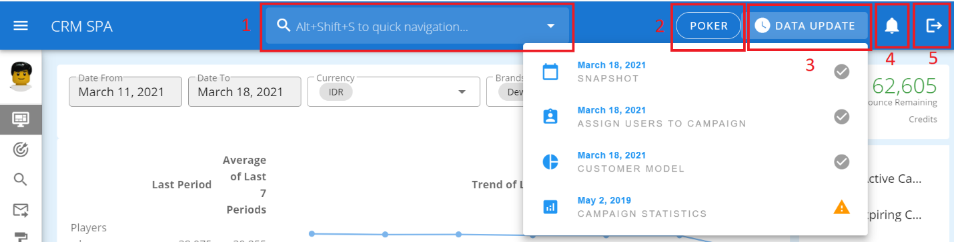
- By Clicking Logout user can end his/her session.

(Figure 1.1 Top navigation bar)
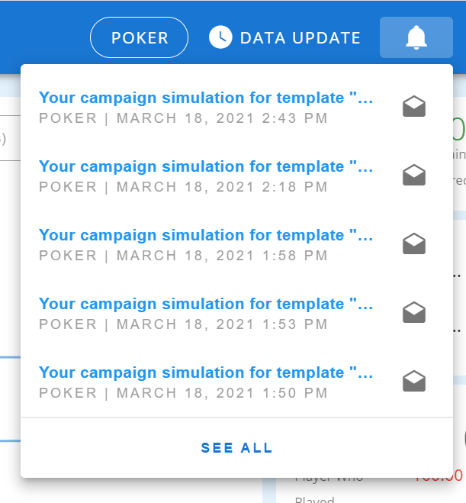
(Figure 1.2 Notification Drawer)
Clicking See All will redirect the admin to the notifications page wherein all notifications received by the current logged in user is displayed. User can select a notification to view the full details. (See Figure 1.3)
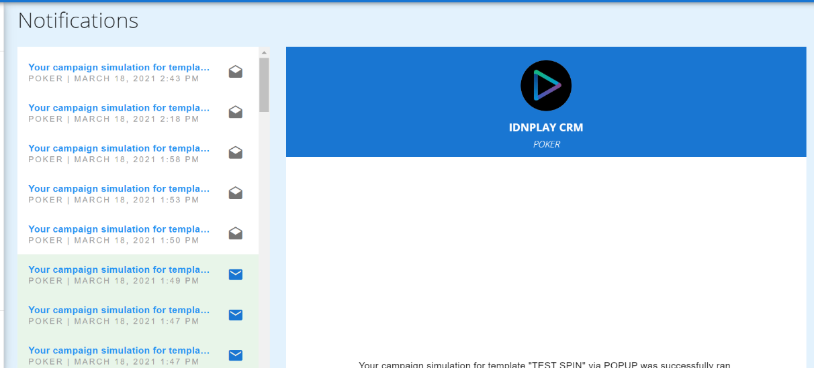
(Figure 1.3 Notifications Page)

DASHBOARD
This is where the system gives a brief idea to the users about the data based on the summary of transactions made by the customers like deposited amount, number of depositors and etc. within the given period and selected game.
The data on this section is computed daily and saved to another table so it will not run a heavy data query.
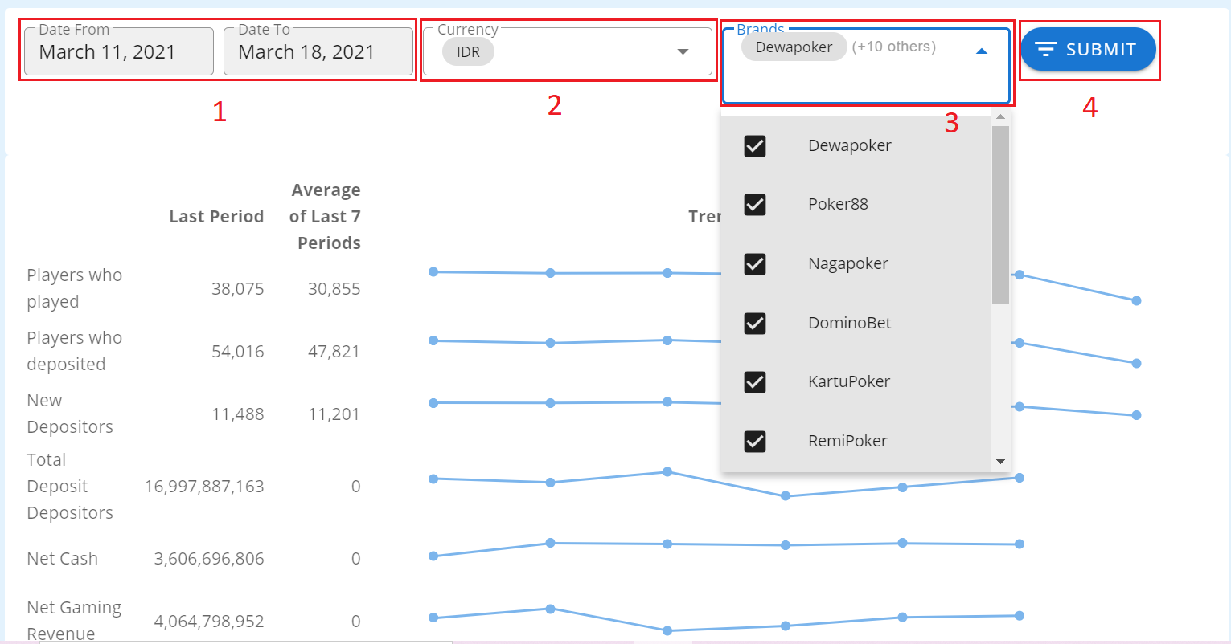
This section is based on Optimove, but there is some modification made on the data that being displayed on this system it is defined daily unlike Optimove 14days or equivalent to two weeks, some of the other KPIs are not available since those values are based on churn, and CLVS.

(Figure 1.4 Dashboard UI)
- By default, the date range selected displays the past 7 days starting from the latest snapshot date. (Refer to Figure 1.4)
- Reports are separated by currency filter since some data are in a different form we can’t aggregates those data because it will give inaccurate and misleading reports.
- User have the capacity to view specific casino report.
- By clicking generate it will change the data that being displayed.
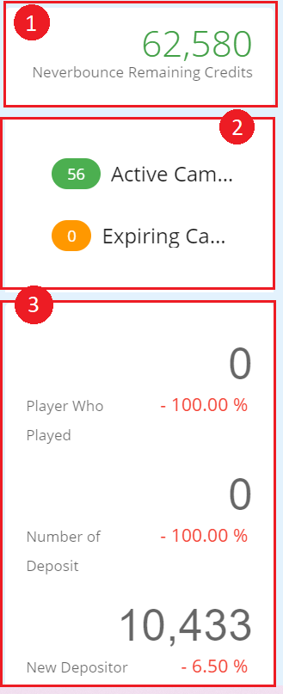
(Figure 1.5 Dashboard UI Side)
- On the right side of the dashboard, the remaining credits for Neverbounce is displayed. A warning notification is sent every time it will drop below 20,000 credits.
- The number of running and expiring campaigns are also displayed. When clicked, the list of campaigns will be shown.
- More information is shown including the players who played, number of deposit and new depositors together with the percentage of its increase/decrease based on the latest snapshot versus yesterday.
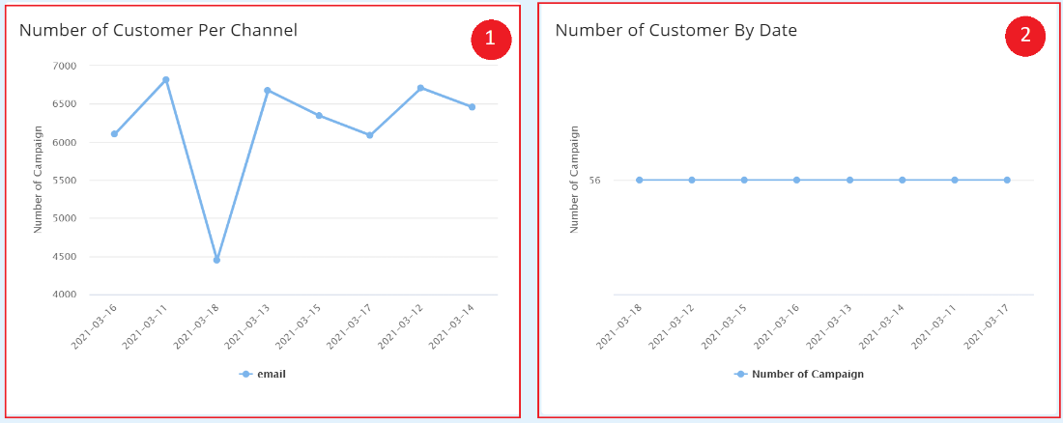

(Figure 1.6 Dashboard UI Below)
- On the lower left side of the dashboard, a line graph containing the number of campaigns per date is shown.
- On the lower right side of the dashboard, a line graph containing the number of customers per channel per date is also shown.

predictive model

Customer Model
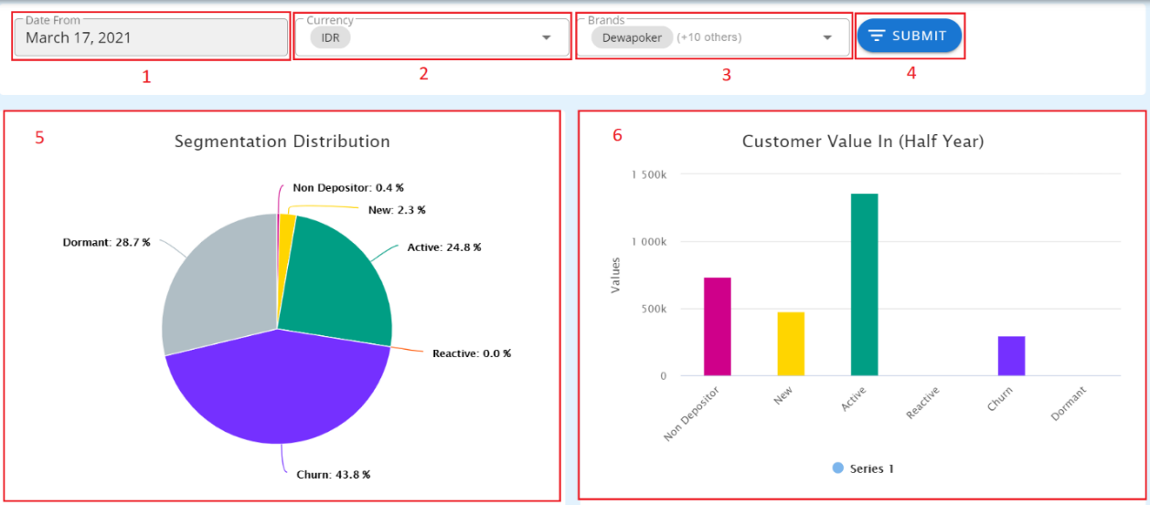
The use of this section is to show the users of the summary of primary segmentations which are defined in Settings > Segmentation. These segmentations change daily based on the customers’ actions, behavior and other factors with the given date range.
(Figure 2.1 Customer Model)
- By default, it loads the latest snapshot date. (Refer to Figure 2.1)
- Since Multicurrency Can’t be aggregated, system provided a currency filter.
- User has the capacity to choose a list of casinos he/she wants to display in a report
- By click the generate, will change the data display on the screen.
- Distribution is the percentage of each segmentation.
- Churn Rate
Churn Rate gives the probability of player not having an activity for the next months. It has value in the range 0 to 100. >50 means high risk of churning. One can use this to reduce the number of Churned customers and therefore increasing revenue. Specifically, one can make a campaign that gives a reminder when the customer’s churn rate exceeded 50 and therefore catch them before they go. Note that timing is important that is why a churn prediction algorithm is implemented.
- The page can be exported as PDF.
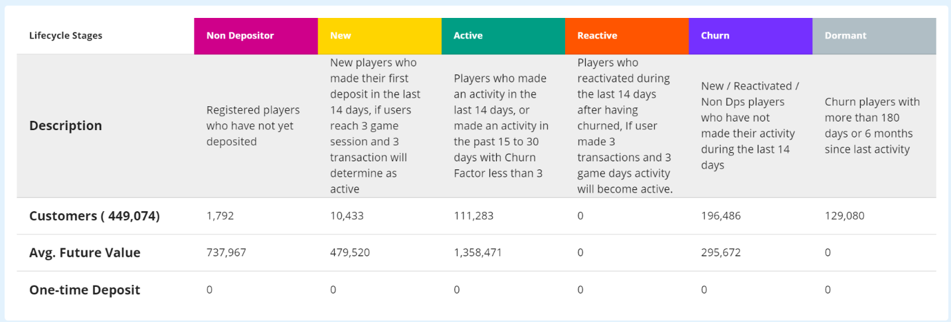
(Figure 2.2 Customer Value)

Analysis & Research

Customer Explorer
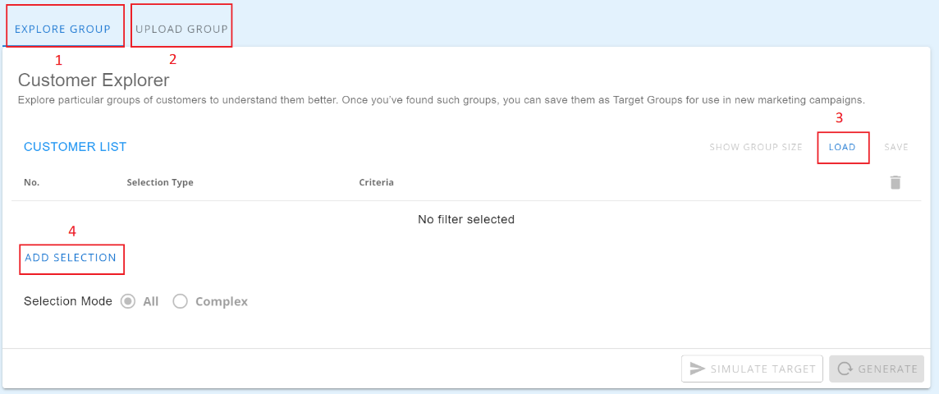
This section is used to generate a list of customers and compare the results based on the given criteria of the user. These criteria were group into three: Most Used Filter, Customer Model, and Customer Activity.

To use customer explorer, visit this link https://retention.dewacrm.com/analysis/customer.
(Figure 3.1 Customer Explorer UI)
- Generating a group of customers.
- Upload particular groups of customers to understand them better.Building a group opens filter tab.
- Load group will show all the saved group target group. (Refer to figure 3.2).
- Building a group opens filter tab.
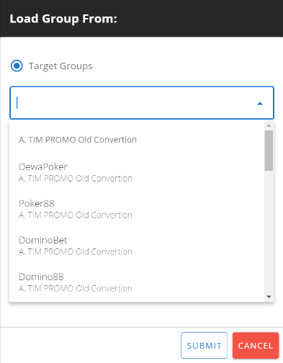

(Figure 3.2 Load Group Form)
I. Building a new group
Building a group of customers can be filtered in 3 Major Sections: Most Used Filter, Customer Model, and Customer Activity.

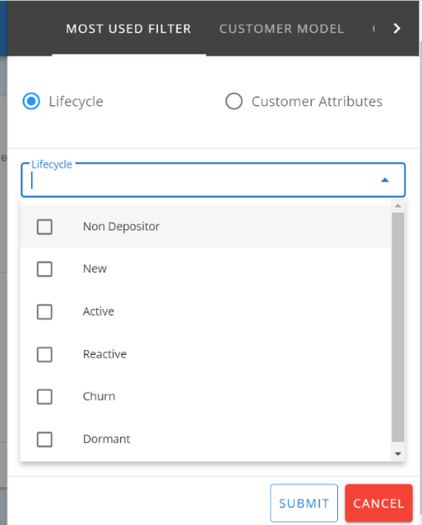
- Most Used Filter This is the basic filtering option. It uses all the available columns in our database.

(Figure 3.3 Lifecycle Segmentation Filter)
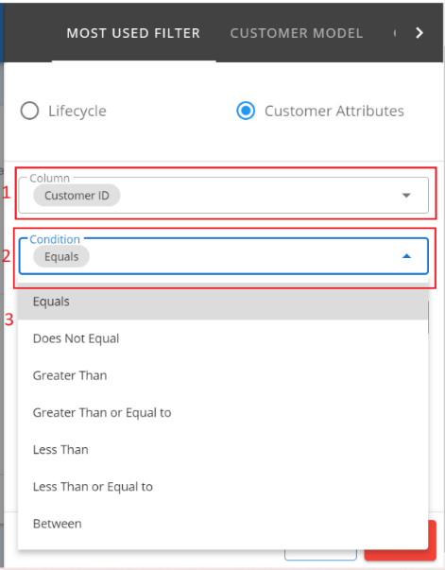
(Figure 3.4 Customer Attributes)

- List of Attributes that can be used on filters. Please refer to this link
https://retention.dewacrm.com/help/columns
- This is the list of operations that is available on particular column.
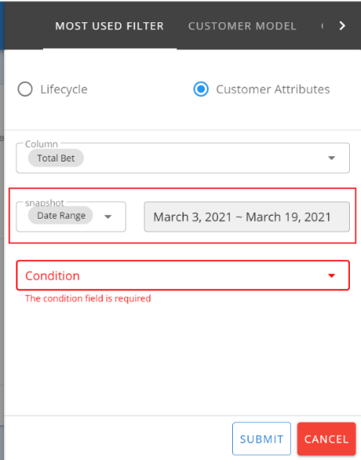
- This is where the value can be inputted and may have different data types. If the columns defined a money it will mask to this format 1,000, if it is date range, it will automatically use date range picker.

(Figure 3.5 Filter with Range)
Some columns have a range filtering in which the user can filter the number of deposit with a given date range. (e.g. If the user wants to filter the number of deposit in the given dates, he can use this filter. As of now, it is applicable to only limited columns)
- Customer Model
Most of the filters here in Customer Model is based on computation.
As of now it’s pending but the Value Segment can be defined on Settings > Segmentation
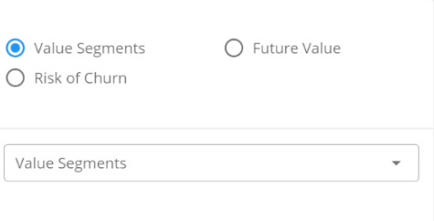

(Figure 3.6 Customer Model Filter)

- Customer Activity
This section is the most advanced filtering happens. It is grouped into different sections: campaign history, game history, activity history, campaign received and campaign conversion.
- Campaign History
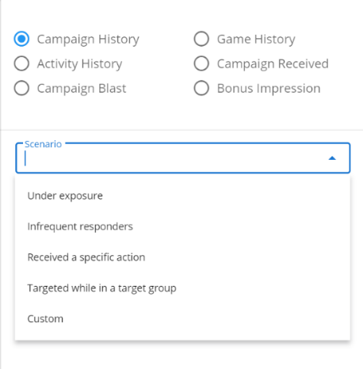

(Figure 3.7 Campaign History Filter)
  - Under exposure – this section filters all the customer exposed or part of a campaign for how many times within the given date.
  - Infrequent Responders - this section filters all the customers who have responded on the campaign for how many times within the given date.
(as of now we can’t identify how many times the customer responded because there is no definition yet).
  - Received a specific action – this section filters the customer involved in a specific test group in a campaign. It can also filter how many times the customer responded or had been targeted in the test group within the given date range.
  - Targeted while in a target group – this section filters the customers involved in a specific target group in a campaign but it does not include the control group. It can also filter how many times the customer responded or had been targeted in the target group within the given date range.

- Activity History
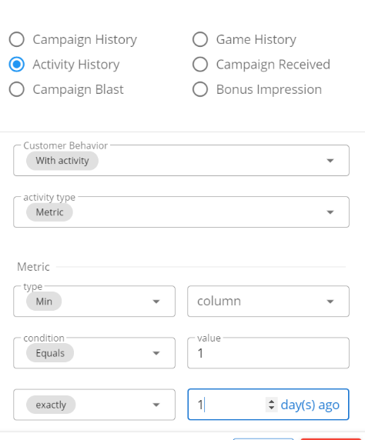

(Figure 3.8 Activity History Filter)
- Metric – this section is used to filter the number of activities by the given attributes with min, max, total and given date range.
Example: I want to filter customer who has a min of 3 deposits in last two days.
- Days with Activity – this section is used to filter the number of deposit in unique days of activity
Example: I want to know the list customer who deposit 2 unique days in 1 week.

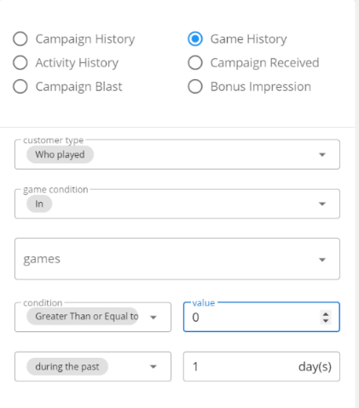
- Game History
(Figure 3.9 Activity History Filter)
- Who Played – this section is used to filter the customers who played a specific game within the given bet amount.
Example: I want to filter customer who played Bandar Ceme with 4000 bet amount.
- Who did not play – this section is used to filter the customers who did not play or did not bet on a given period of time

- Campaign Received
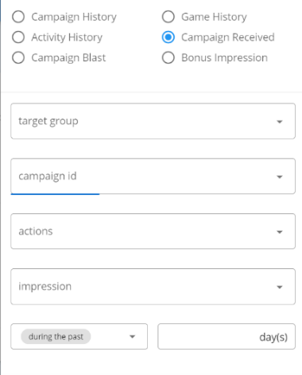

(Figure 3.10 Campaign Received Filter)
- This filter selects the customers which are targeted in a specific target group, campaign and test group. Unlike Campaign History, this section is more specific.
Example: I want to see all customers targeted in Churn and has a campaign ID of 1 and included in a Test group of “Test”.

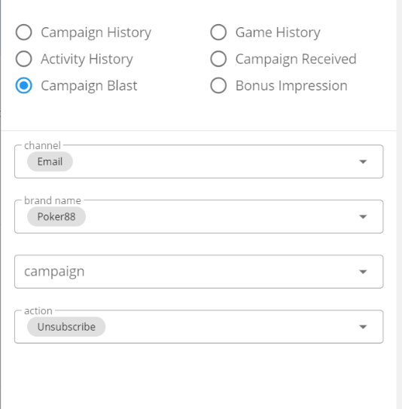
- Campaign Blast

(Figure 3.11 Campaign Blast Filter)
- This filter selects channels and what actions they want to do in a campaign selected for the brand.
Example: I want to see the email campaign for the brand with unsubscribe action.
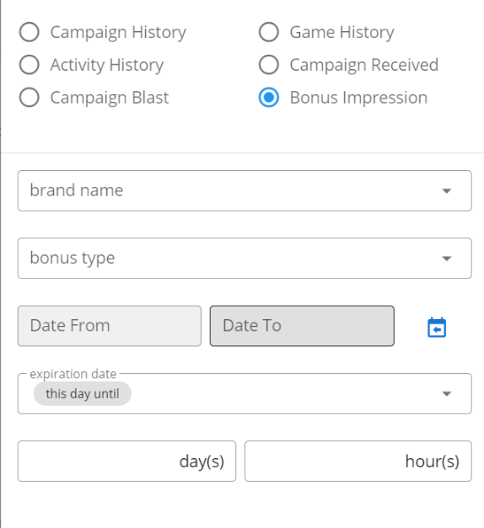
- Bonus Impression

(Figure 3.12 Bonus Impression Filter)
  - This filter selects the bonus type for the brand from the date range selected and expiration depending the date and hour/s selected by the user.
Example: I want to see the brand brand bonus type for the date range and expiring in 2 days and 3 hours.

- Campaign Channels
This section is for advanced filtering by channel.
- Email Channel
This is used to filter only unique email address whereas they can be chosen based on an order. For example, we have five customers with the same email but different users, this happens with brands if the email is not unique, so sending of campaign would be multiple. To reduce risk on reputation of our SMTP, this filter may be used.

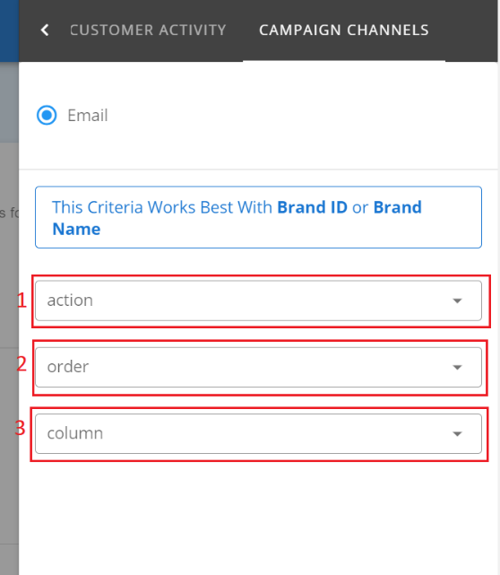
(Figure 3.13 Email Channel Filter)
      - This filter works better if has a criterion for brand ID or name. The user will select an action to take which is Unique Email.
      - Then the selection of the unique email will be chosen by an order which could be descending or ascending.
      - The order of the multiple email addresses will be based on the chosen column: balance, registered date, last login, first deposit date, second deposit date and third deposit date.
II. Uploading Group
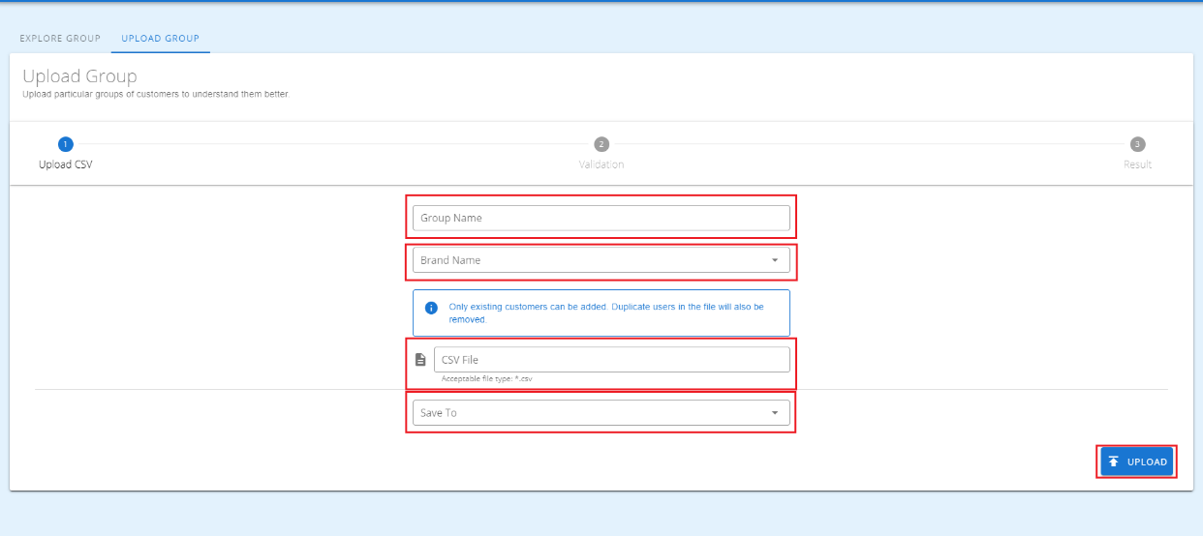
Upload particular groups of customers to understand them better.

(Figure 3.14 Uploading Group)

III. Loading a group
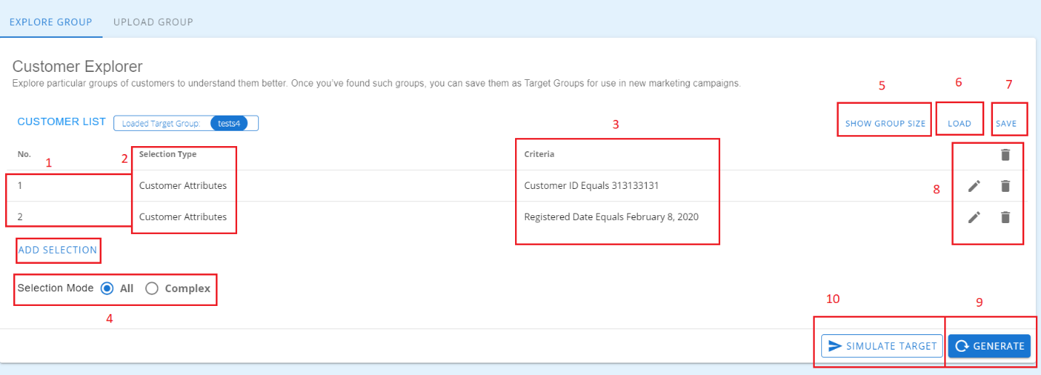
User can load groups of criteria on target group or exploratory group.

(Figure 3.15 Exploring Customer Group Details)
- This indicates the number of criteria that can be used on building a complex group.
- This displays the type of filter which is being used. (please refer to building a group)
- This will display the complete details about the filter, if the details are too long, it will be truncated and makes it display on hover so that it would not overflow.
- There are two types of selection mode: ALL and COMPLEX. All is for beginner users who don’t have any idea about Logical Operator AND/OR, and just runs all the filters in order.
Example: Active with 3 Number of Deposit.
Complex is for advanced users who want to make their criteria more flexible.
Example: I want to target all customer that contains @yahoo.com or @gmail.com on their email address, if we make it in complex, it should be like this (1 or 2), hence if we run this one without using complex, to be able to get a result we should have a test@gmail.com@yahoo.com on our data.
- Show Group Size will load the number of customers who met the criteria.
- Load Group will load a saved group in our database.
- Save Group is to create a campaign or just to save and view later.
- The pencil icon is the action button which acts as edit where the criteria can be edited or replaced with another selection type while the delete icon is to remove a selected criterion.
- After clicking Generate, it will load the customer information and the summarization of the group (refer to Figure 3.15)
- We can use the criteria listed to simulate a template campaign (Popup, Email or API)
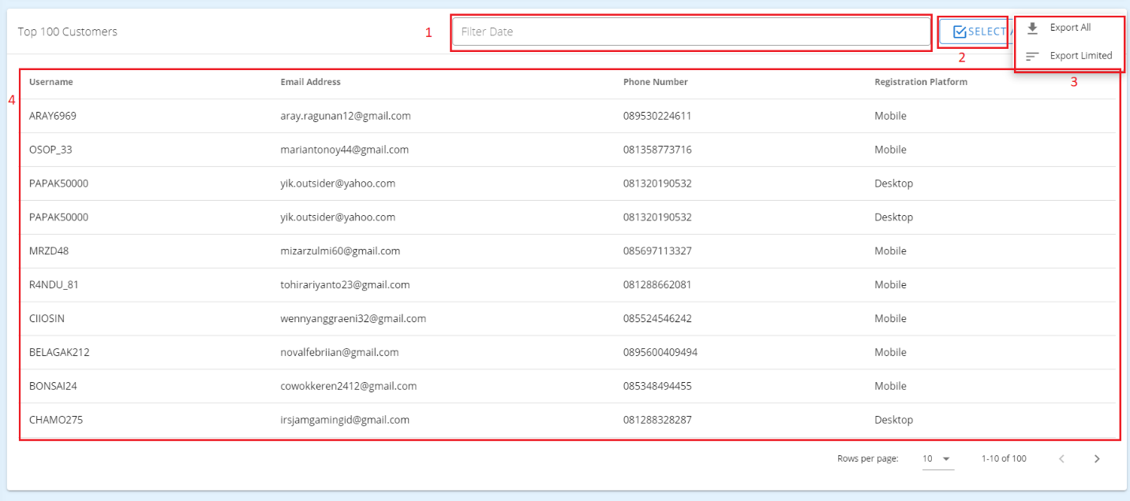
(Figure 3.16 Result when generating the criteria in group explorer)
(Key Group Characteristics is based on total customers’ information including those not in the top 100 customer)
- Data can be filtered by date.
- Selecting displayed attributes can be modified. (Refer to Figure 3.16)
Example: I want to view the customer’s email, alias or balance in the summary, top 100 section, and exported CSV.
- Since the data displays only the top 100 customers, we can export all the list in a CSV file. But for some criteria, it may take too much time depending on the number of customer and attributes to be exported.
- This section displays all the customer’s information based on his/her data saved in our database.

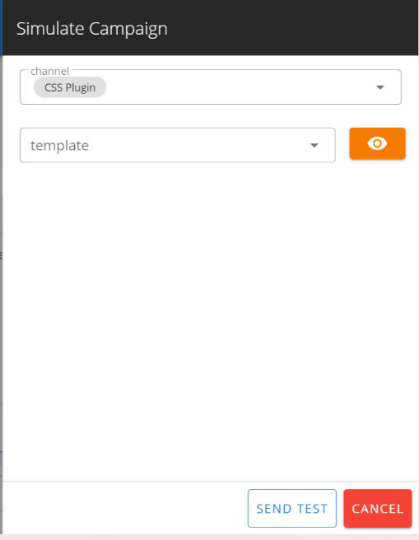

(Figure 3.17 Simulation of Campaign)
A user can also simulate or test the campaign if he wants to get a preview on how it will be displayed in a customer’s view. For popup, users should open the website to that corresponding customer.
Example: If I’m a customer in Dewapoker, the user should open his account on Dewapoker so we can view or simulate the popup.
For email, and API notification no need to open the site, just open the email and if the API is on, they can check if the requested API is working.

Customer 360
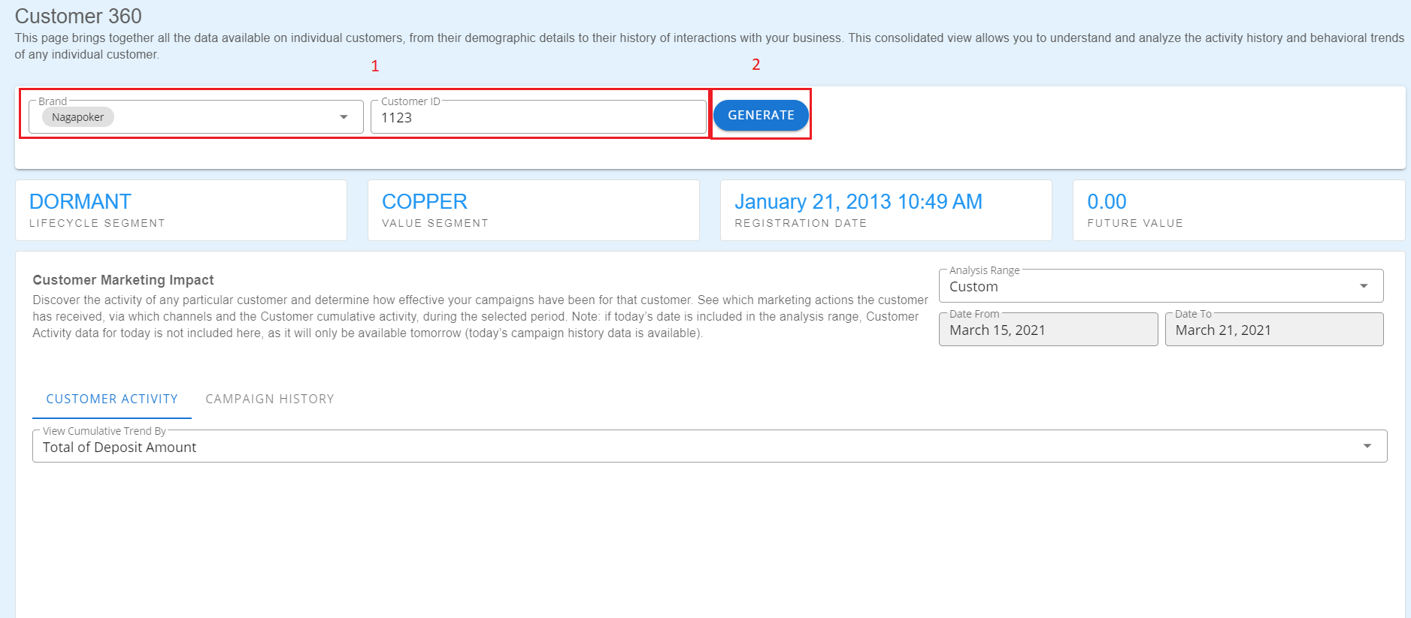
Customer 360 will give some idea about individual customer engage on a campaign, it also shows the increase per day and the response of customer in campaign.
(Figure 3.18 Generate a Report on Customer 360)
By putting a brand, valid customer ID and clicking the generate, it allows users to show a report about the customer engagement in a campaign.
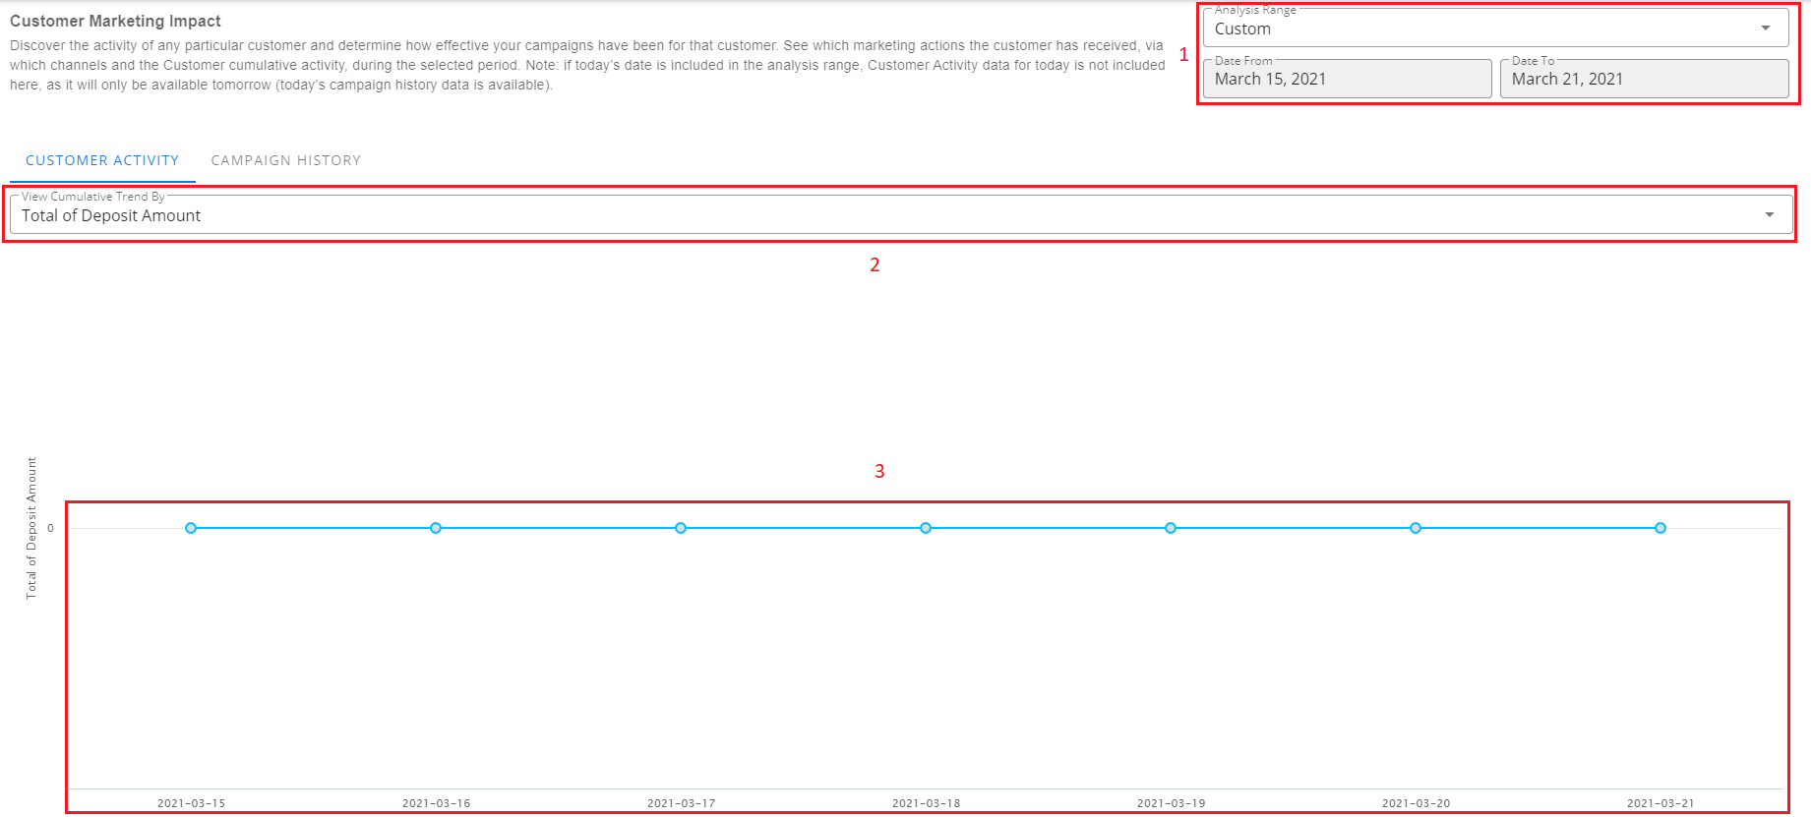
(Figure 3.19 Generating Statistical View of Transaction and Game Activity)
By setting the date range and transaction, it will show a graphical view of how the transaction changed and also how many times the customer had been targeted in a campaign.

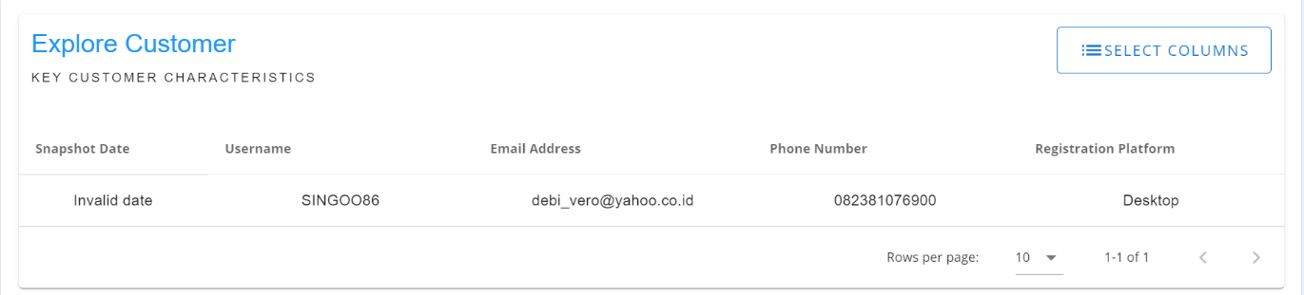
(Figure 3.20 Daily Snapshot of Customer)
By default, this section shows the daily snapshot of the customer. It started on the latest snapshot date up to the date set in Figure 3.19.

ONE-to-one campaigns
Creating a Folder Group
1. Creating a group
a. When click folder name will appear (b) as seen in figure 4.1.
b. This will appear when (a) is click as seen in figure 4.1, the user can name the name of folder depending the category that he/she will add.
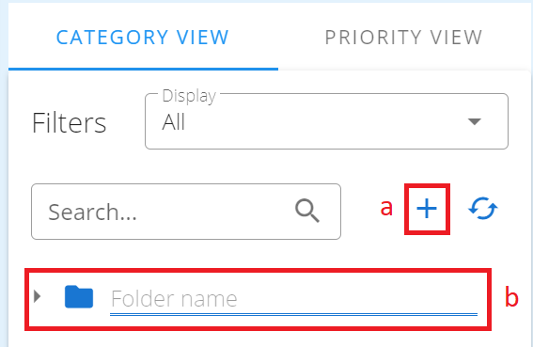

(Figure 4.1 Creation of folder)

2. Group Editing/Deleting/Renaming
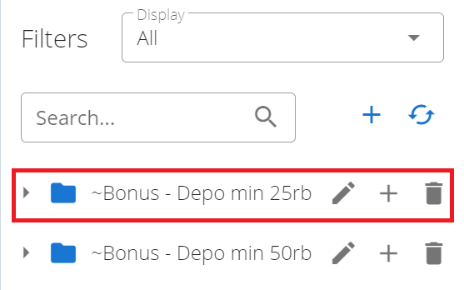

(Figure 4.2 Folder Group)

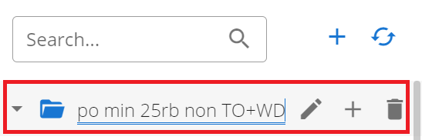

(Figure 4.3 Clicking Pencil icon on a group)
Fill the field with a new unique name then press Enter to save, otherwise press Esc.
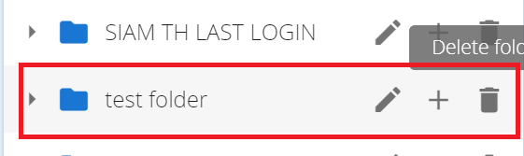

(Figure 4.4 Clicking Trash Icon on a group)
The trash icon deletes a group. An alert message will appear for confirmation, click OK to continue deleting the group with all its content, otherwise click Cancel.
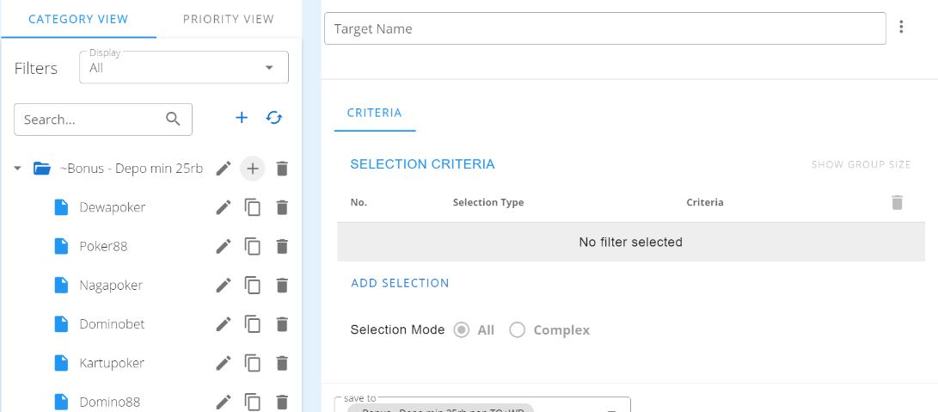

(Figure 4.5 Click plus icon on group)
By click the plus icon it will show the information you need to fill to create a certain item.

Campaign Planner
This section is the calendar of scheduled campaign in the current month.

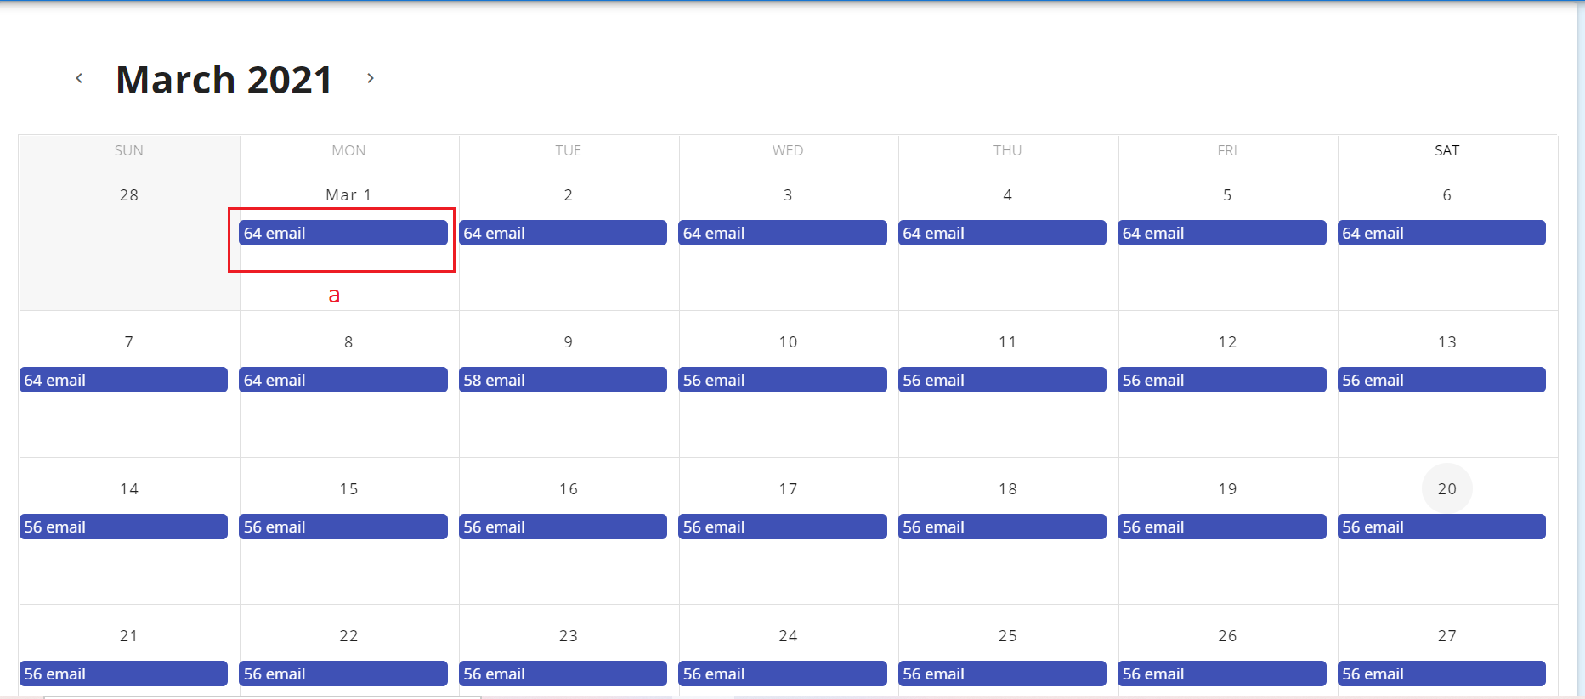
(Figure 4.6 Calendar of Campaigns)
  - When click it will show list with further details about the scheduled campaigns.
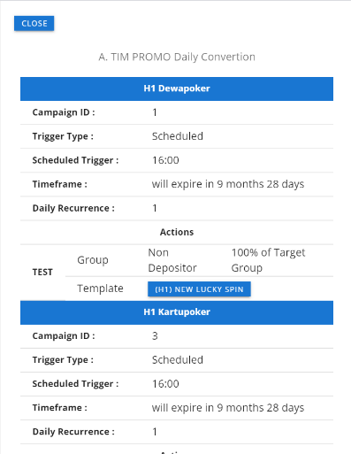

(Figure 4.7 List of Campaigns in the Selected Date)

Target Groups
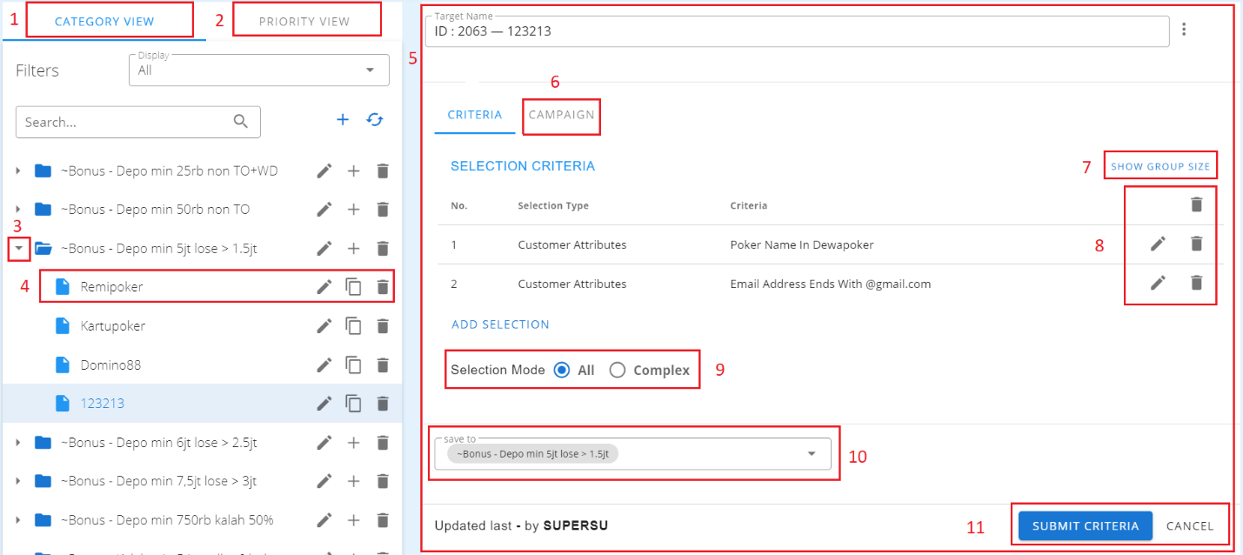
This section is where the groups made in customer explorer takes place (See Figure 3.12). Unlike Customer Explorer, in this part, users can create a campaign and set a priority in each of the campaign.
(Figure 4.8 Interface of Target Group)
- This is where the group of criteria is saved and display in a categorical view.
- This is where the criteria are saved based on priority of a campaign wants to display
- By Clicking the arrow down icon, it shows all the criteria saved in that particular group.
- Upon clicking the item or the criteria it shows the information in the right side of the screen.
Example: Target group 1 should be the one to show if the criteria in Realtime Triggered is met. If it is existing on another target group, it will not be triggered unless the target group 1 was satisfied because it’s the order that should be followed.
- Criteria of particular item.
- This is where the campaign will be created (see figure 4.7)
- By clicking the show button, it will display the number of customers in that criteria.
- Action button (See Figure 3.15)
- Selection Mode (See Figure 3.15)
- This is the group name in which the file is included.

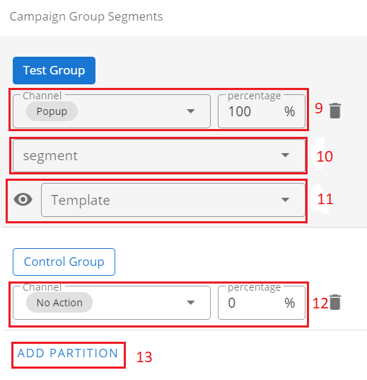
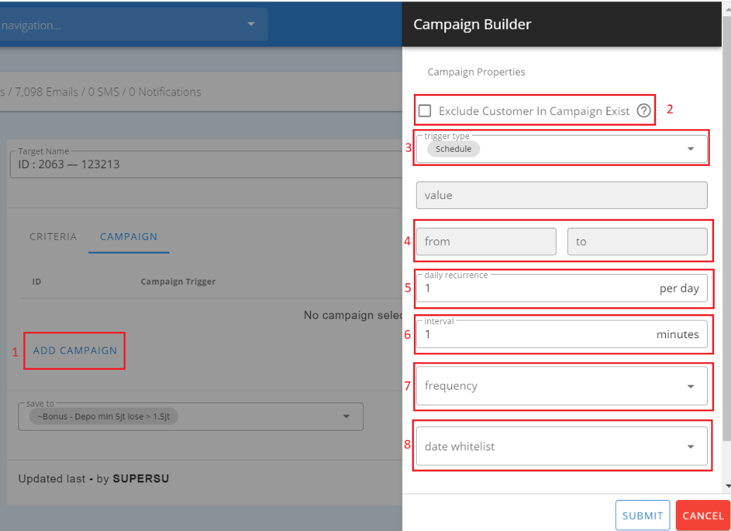

(Figure 4.9 Creating a Realtime Campaign)
      - By clicking Add Campaign, it will show the right sidebar options.
      - Checking it will prevent customer/s in receiving campaign if they have been already targeted.
      - Realtime Trigger is the set of conditions in Manage Realtime Trigger module, these conditions need to be satisfied before the campaign will be sent.
      - This is the span of the campaign should run.
      - Daily recurrence is the number of triggers or the sending of a campaign occured.
Example: If the Realtime Trigger is met, I want to show it 5 times daily.
      - Interval of sending in campaign.
      - Days of the week can be selected in how frequent the campaign will take place.
      - Data with date/s whitelisted.
      - This is the channel or the type of campaign should be sent.
      - This is where the users set the name of the groupings taking place because in campaign, the targeted customers are sliced into groups to view the increase in campaign.
      - This is where the template is set based on channel.
      - The control group is where we don’t send any campaign in the list of customers, this helps the system compute the increase between the one who have received a campaign and the one who does not receive any.
      - By clicking add action, it will show another list of groups if the user wants to slice the customers into another group and send them to a different channel and template.
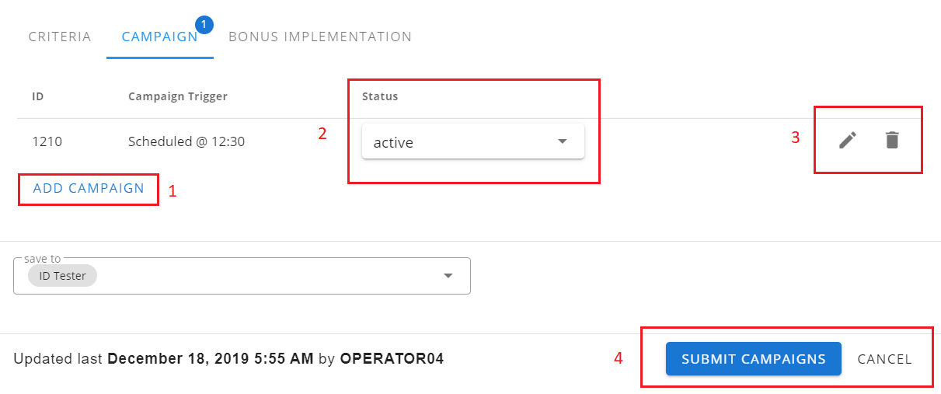
(Figure 4.10 Details of Created Campaign)
- If the user clicks, he/she can add another campaign on that target group.
- If the user wants to pause a specific campaign, he/she can set it on this part.
- User can save or cancel the changes made in target group.
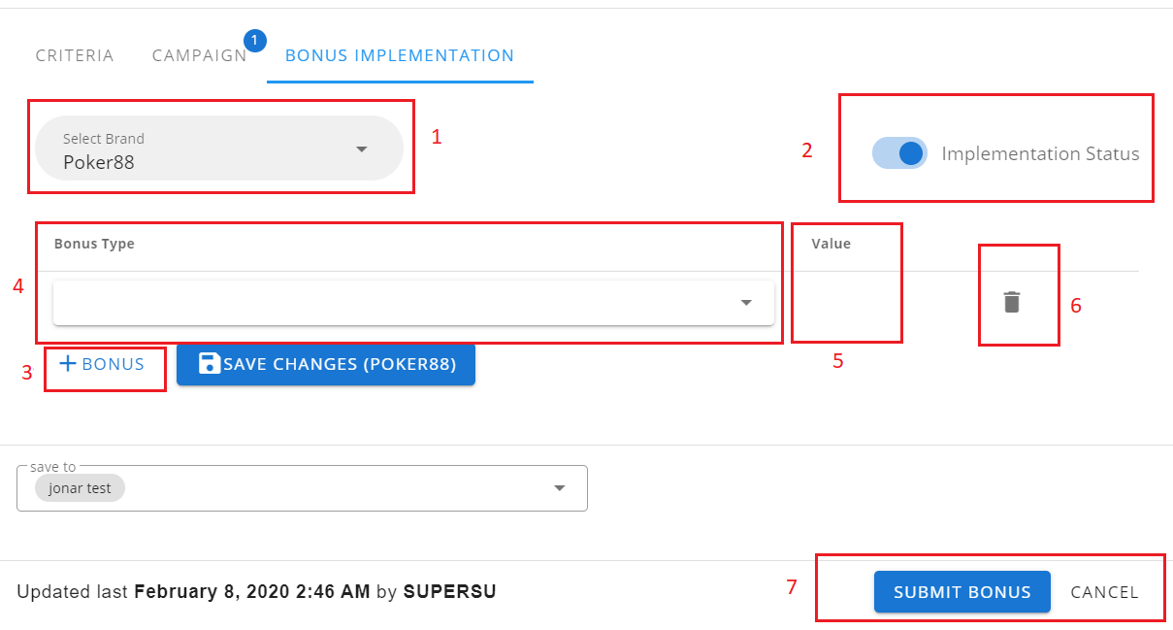
(Figure 4.11 Implementation of Bonus system)
- User can select which brand to use.
- Activates the status of the bonus system.
- User can add the bonus type for the brand selected.
- List of the bonus type added by the user.
- Bonus type value.
- User can delete the bonus type.

Segment Conversion
The segment conversion metric measures what percentage of players change from one type to another type. This is for long term campaigns since players will not change the segment type most of the time. This is useful for example; a user wants to know if a campaign is good in decreasing the percentage of churned customers (increasing revenue) in the long run by comparing test and control group.
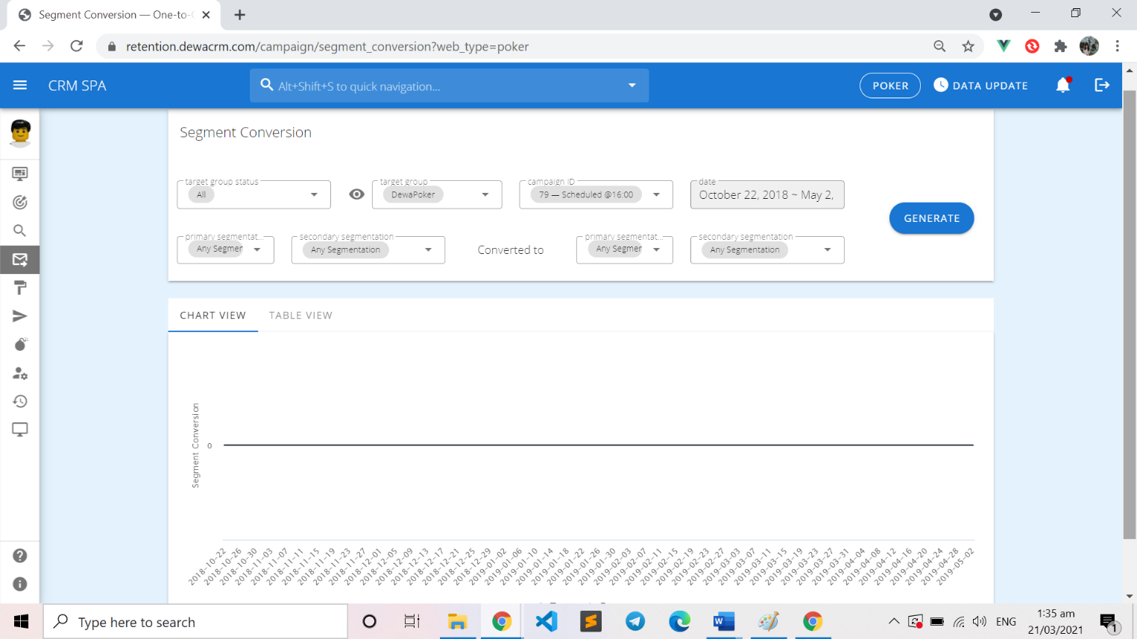
(Figure 4.12 Segment Conversion Filters)
The user must select a target group, a specific campaign and the date range of the analysis to be generated. Then, the user will select in which available segmentations will the customers be converted to and from. (e.g. New-Any Segmentation to Active-Any Segmentation)
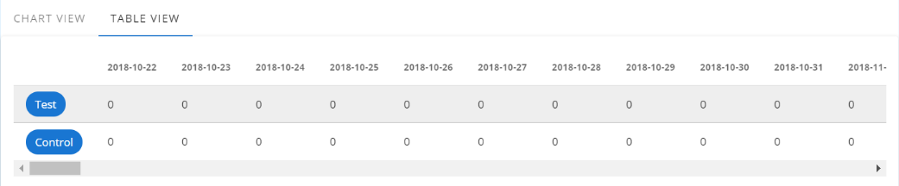

(Figure 4.13 Segment Conversion Sample Analysis Results)
Only the customers targeted on the first day of the realtime campaign from the date range will be involved throughout the analysis. The line graph will show the day-to-day conversion activity of the customer. The bar graph will show the overall performance based on the last day of the range.

Campaign Impression
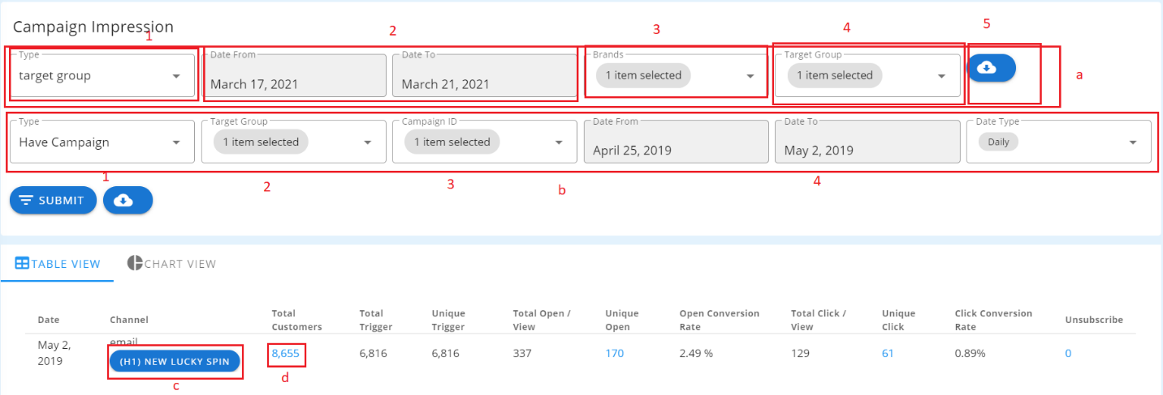
This module let the user monitor the system campaign, if it is sending, how many times it has been sent, how many customers are targeted in the test group.

(Figure 4.14 Campaign Impression in Table View)
- Download Report
- Choose type between target and date.
- This will define the range of the report by date.
- This will fetch brands user will choose from.
- If the type selected is target group it will show all the campaign groups,
By choosing the date, date type will be selected (daily, weekly and group).
- Choosing this will generate
1. User will choose the type of campaign to generate.
2. By clicking and choosing a target group populate the list of campaign available.
3. Will fetch available campaign for the first criteria selected, and by choosing the campaign date range and date type will automatically be filled by the data from campaign selected.

- By clicking this the user can preview the email campaign template.
- View customers will popup by clicking this.

Churn Report
This module is used to track the churn rate. User can view or download the data statistics.

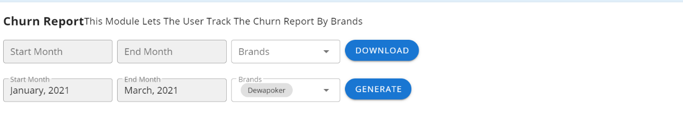
(Figure 4.15 Churn Report Page)

Template
This module contains all the templates which will be used by different campaigns through a channel which may be a:
- Email
- Webpage popup
- API (SMS, Webpush or any another API webservice)
- Browser Notification
- SMS
All the template creations have groupings so the user can easily organize his/her things when data becomes so huge.

Email
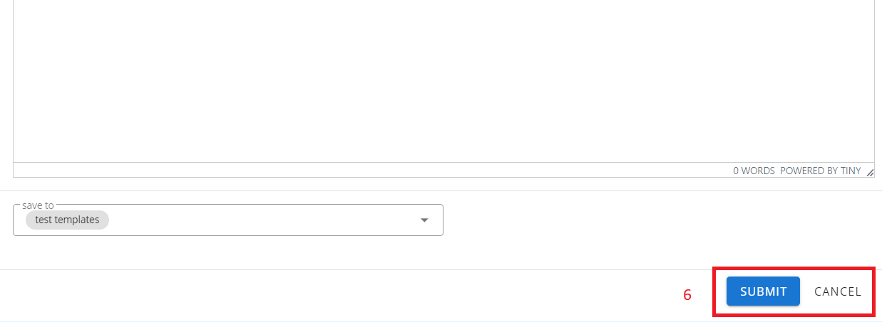
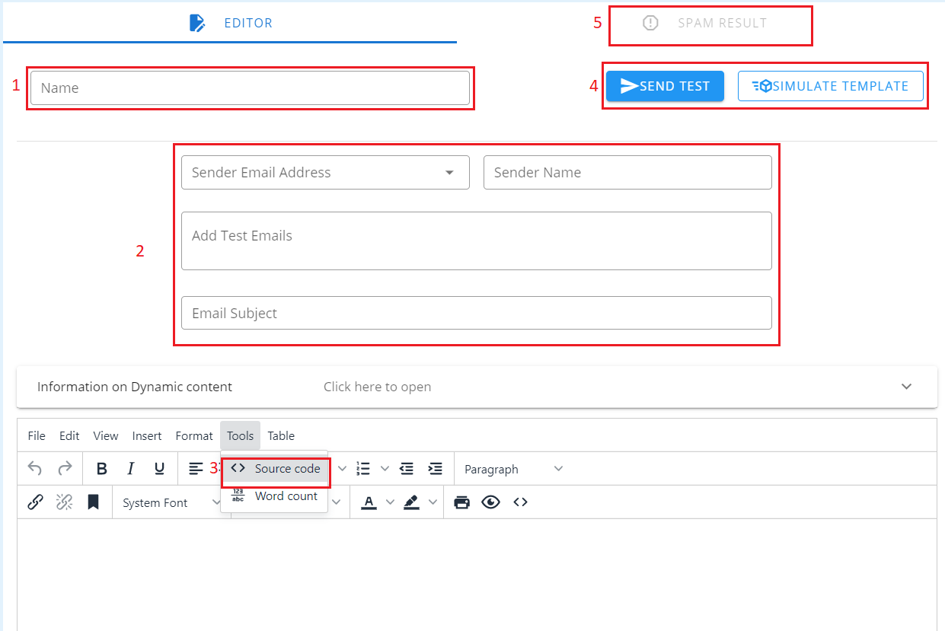
This submodule contains all email templates and allows the user to create, update, delete or test an email template and categorize them according to their desire.

(Figure 5.1 Email Template)
- User will input the name of the email template.
- This is where all the necessary details will be fill up.
- User will paste the HTML file of the template.
- User will need to check the spam words for the email (refer to figure 5.2).
- User can also send test or simulate the email to see if it works for different devices.
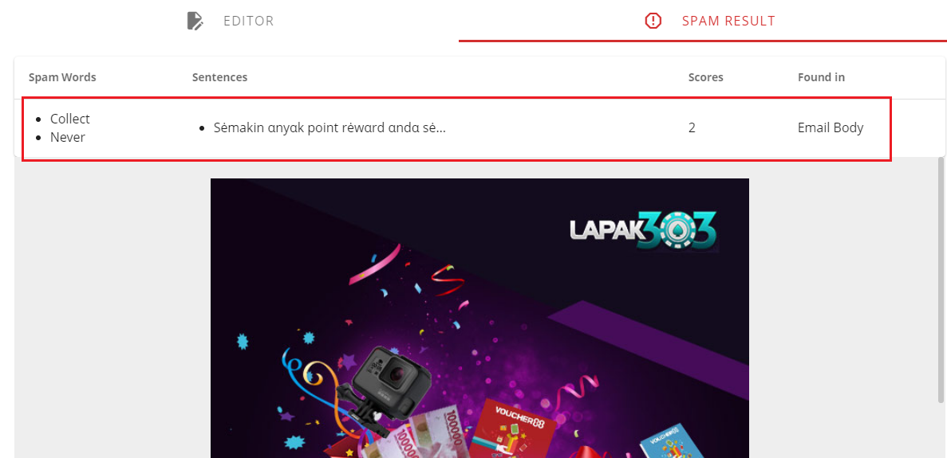
The user has the ability to make the email dynamic same as popup, just use square brackets then inside of it will be the column name. Dynamic values are only applicable in subject and body.
(Figure 5.2 Email Template Spam Words Result)
Now the user can see the spam and in what sentence it is from so he/she can change the character/s for the word so that it cannot be considered as spam.

Webpage Popup
On creating a webpage popup, you can choose either you want to upload the file, or create your own html, or even iframe. The size of the popup may be customized by filling up the Padding, Height and Width fields. There will be three ways a popup can be made:

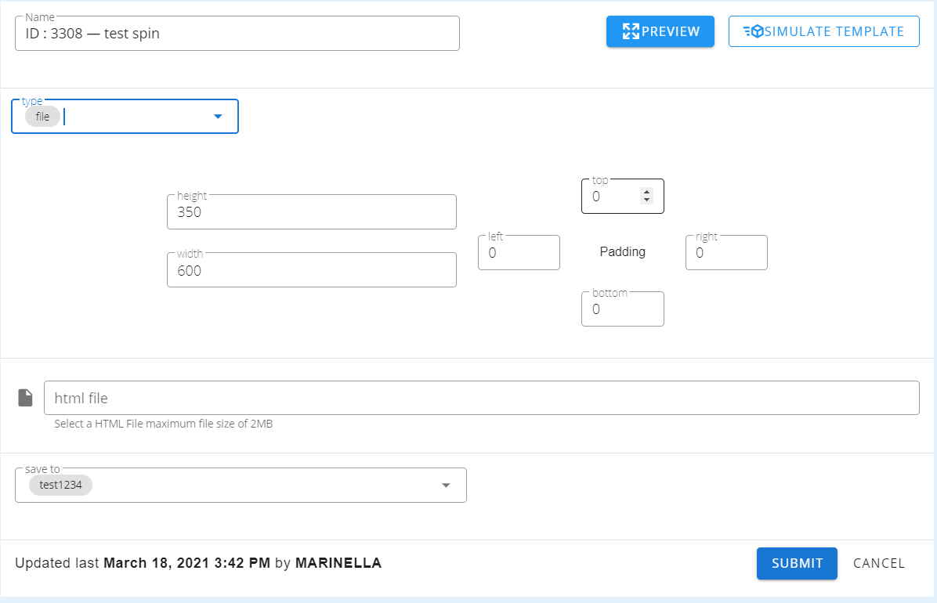

(Figure 5.3 Creating popup using file)
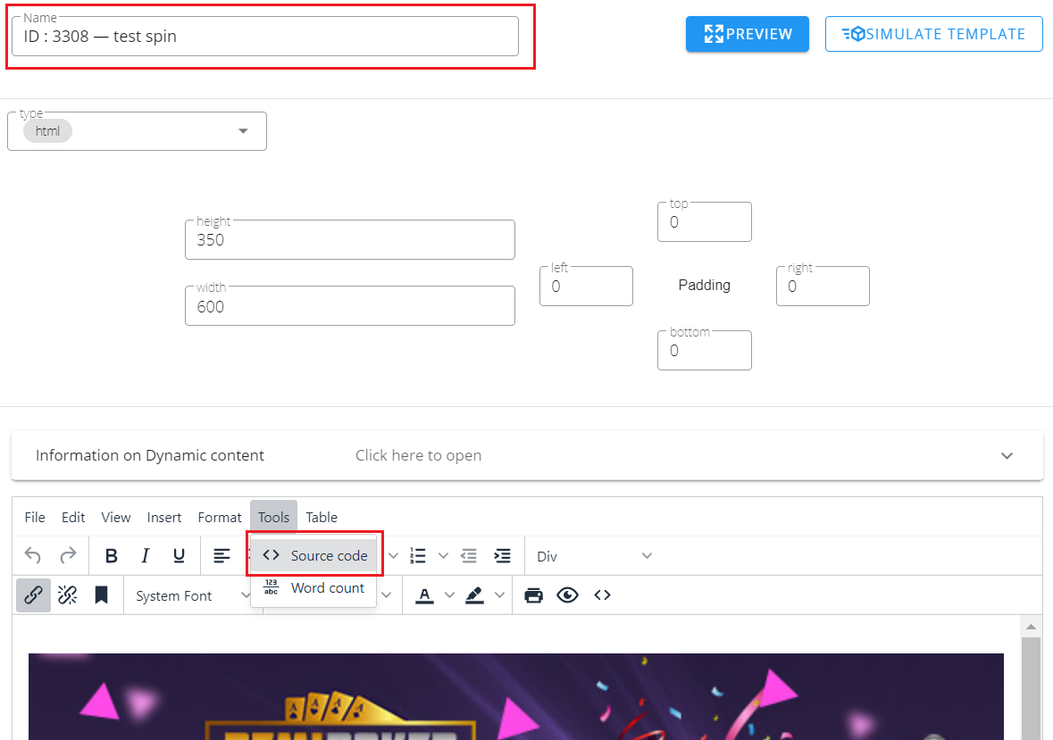
Click the Choose File button then select the chosen file to be uploaded then click the Save button.

(Figure 5.4 Creating Popup Using HTML)

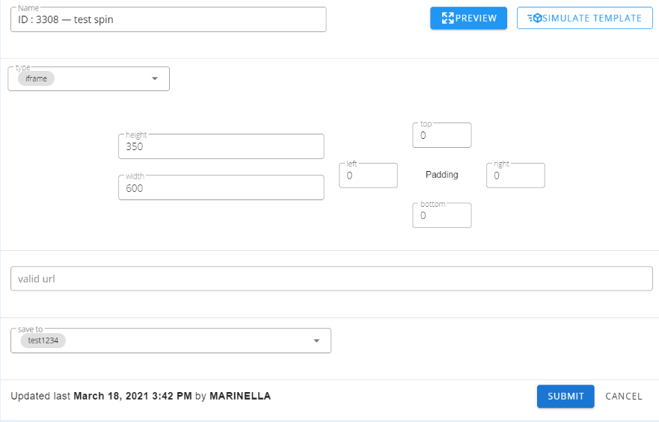

(Figure 5.5 Creating Popup Using iframe)

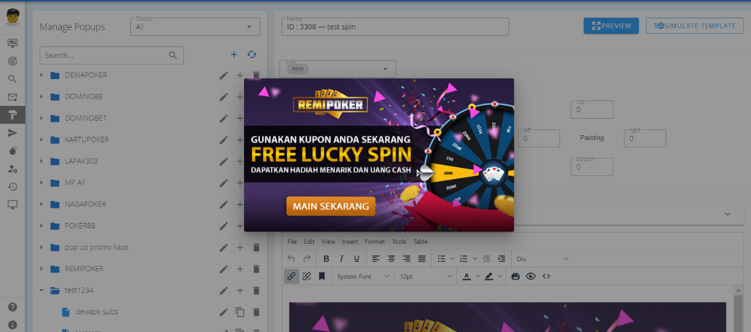
For creating an iframe popup, user should input a valid webpage address.

(Figure 5.6 Preview of user created popup)
User can make the popup dynamic based on customers details and transaction, by adding square brackets. Inside those brackets is the column name, it will automatically inject all the customers details before it send so that it will be dynamic.
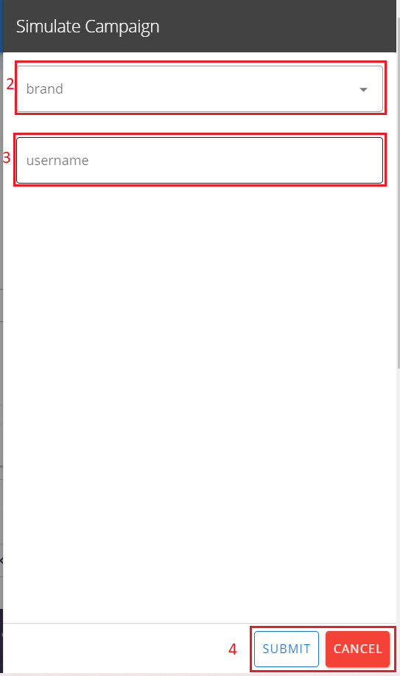
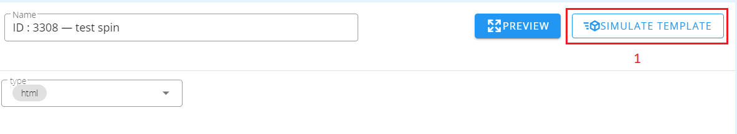

(Figure 5.7 Preview simulate template)
- Upon clicking the simulate popup will show
- User can select which brand the preview will be shown.
- The username that is logged in the website the preview will be shown.

Manage SMS
This submodule contains all SMS templates where they can create, update, delete and test send. This channel uses Plivo. (currently not in use and is still pending)
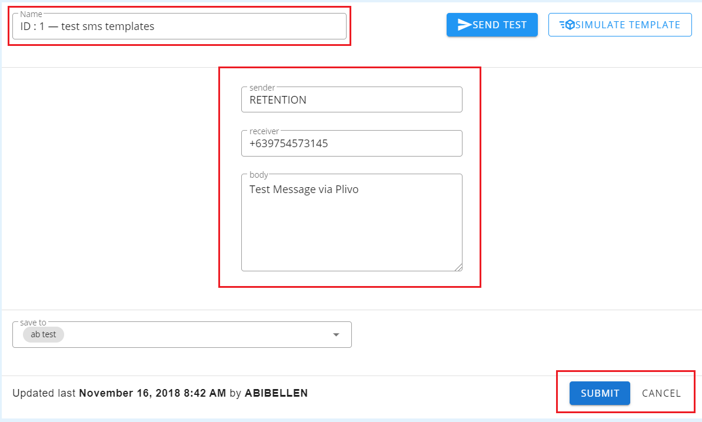

(Figure 5.8 Preview SMS template)
A test sender name and receiver is required in order to send a test message to a registered number. Then the Message field, same with the notification and html popup content, can also have dynamic fields.

Notification
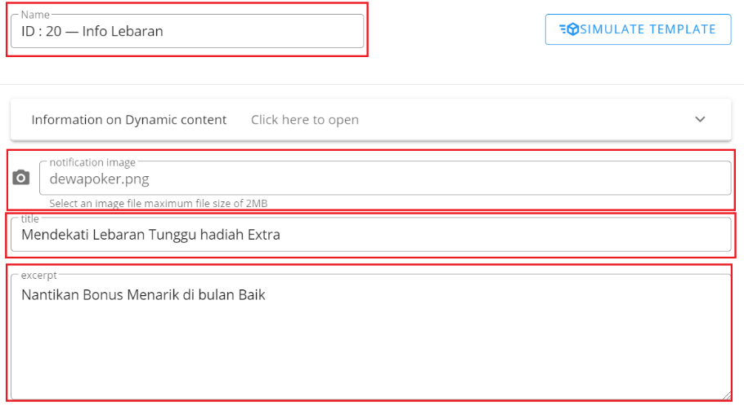
This submodule contains all browser notification templates where they can create, update and delete them and categorize them by folder.

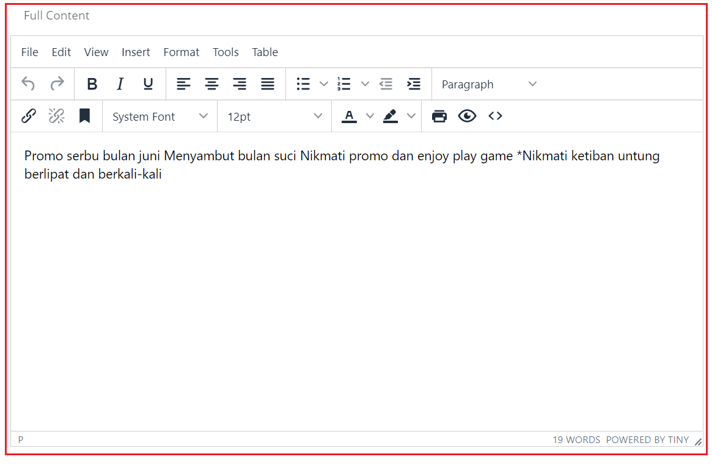

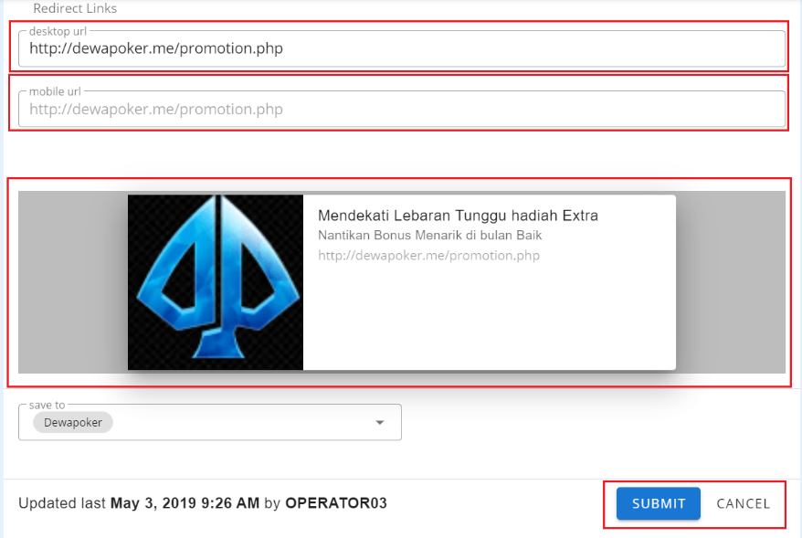

(Figure 5.9 Notification Template Creation)

The user can upload an icon by clicking the Choose File button (recommended size is 192x192px). The Notification Body is the details shown in the sliding browser notification itself while the Full Content is the one shown on the notification drawer inside the website. The Full Content field, same with the HTML creation of popup, can have dynamic fields. Then the Redirects To (Desktop and Mobile) fields are for which URL the user must be redirected after the browser notification is clicked.

CSS Plugin
Adding CSS design to the link you want to update the style of the webpage.

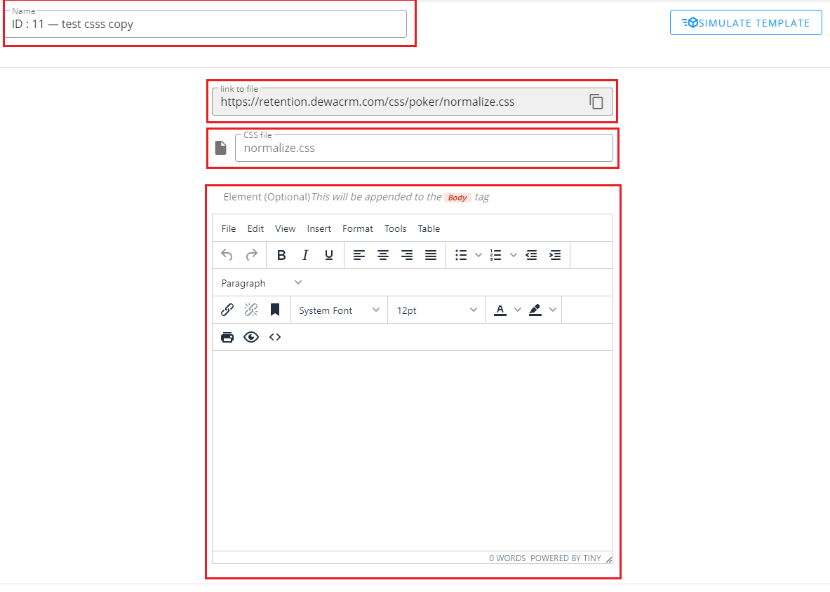
(Figure 5.10 CSS Plugin Creation)

Email Blast
This module allows the user to create email contact groups, email campaign list and check the conversion of the created campaigns.

Campaign List
This submodule is where the user has the ability to view and create email campaigns.
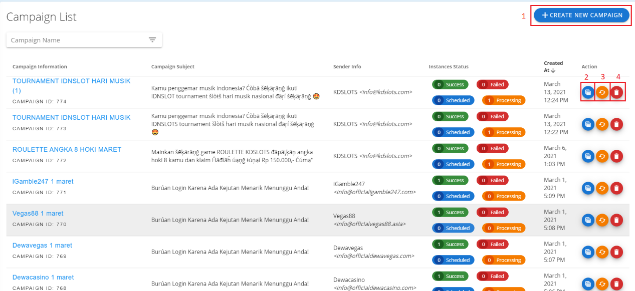
(Figure 6.1 Campaign List Table)
- This button will redirect the user to the Create New Campaign page. (See Figure 6.2)
- Clicking Instances Report will pop up a modal showing a list of all the instances of a campaign. (See Figure 6.3)
- Resending a campaign can be done by clicking this button. Another tab will open wherein the user can choose which email sender and which contact group will be targeted by the resending of the campaign. (See Figure 6.5)
- A campaign may be deleted by clicking the Delete button alongside the row of the campaign chosen.

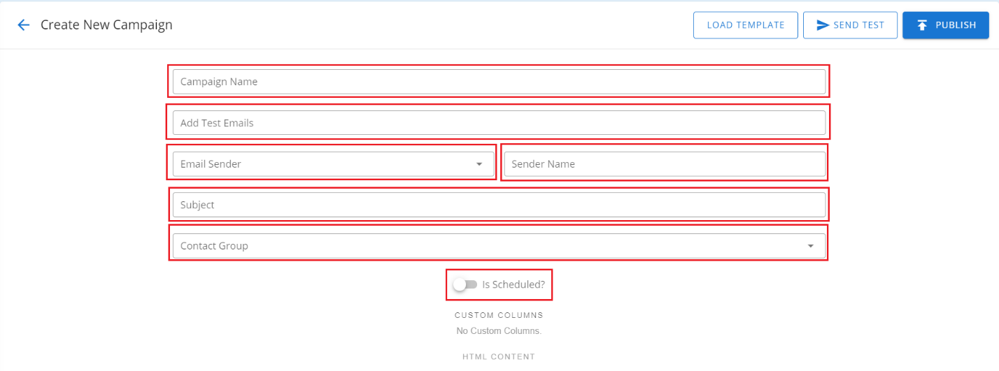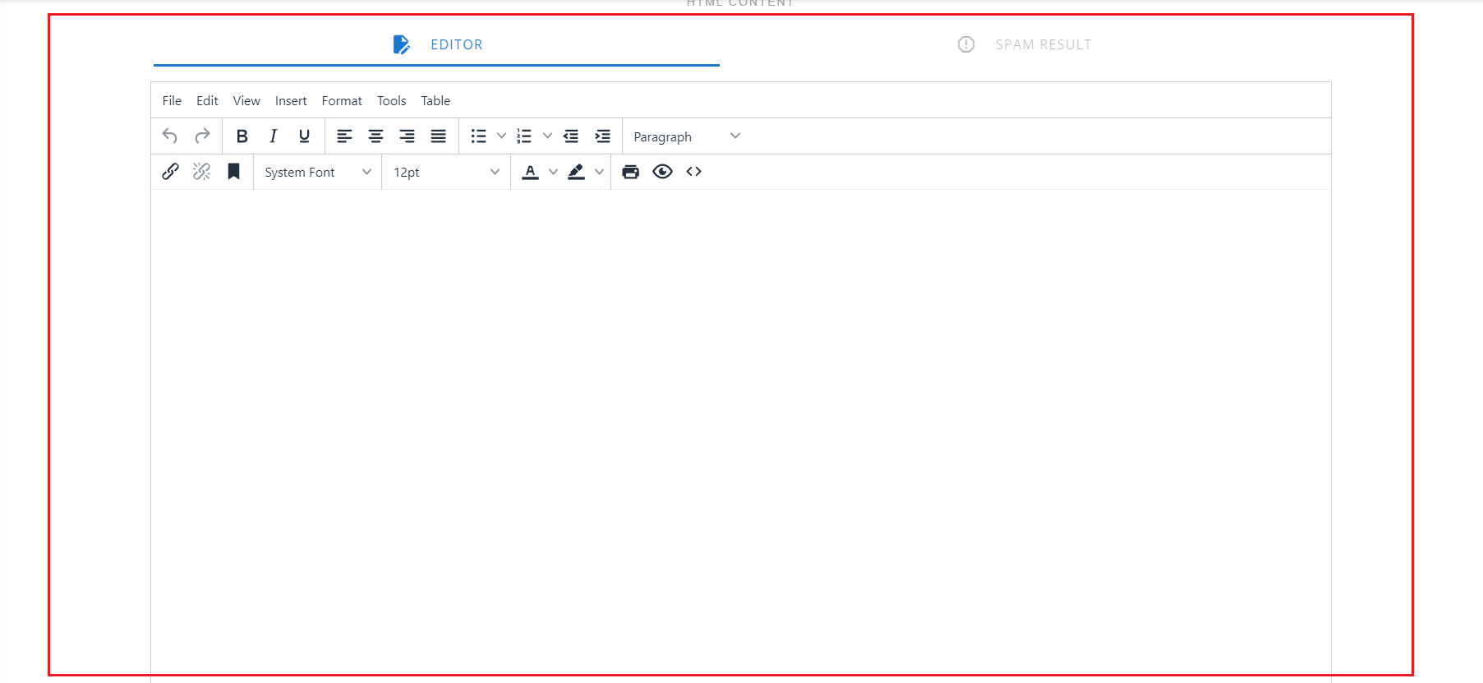

(Figure 6.2 Create New Campaign Window)
All fields highlighted with the red boxes are required. Test Emails must have at least one recipient. As for the Contact Group field, the user may create a contact group first in the Contact Groups submodule. Within the Editor, the user can create dynamic text using %%unsubscribelink%% for the injection of the unsubscribe URL inside an anchor tag and %%DATETODAY%% for showing today’s date. Before publishing the campaign, the user may spam test (beta) it first. All the words which may deem the email as spam will then be highlighted in the Spam Result tab beside the Editor.
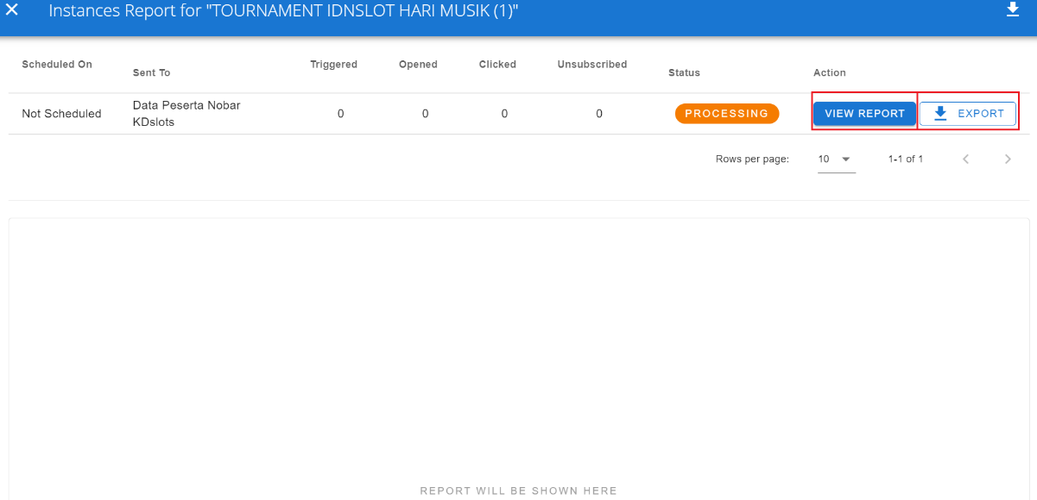

(Figure 6.3 Instances Report Modal)
All the instances of a campaign are shown inside this modal including information on when it was scheduled, to which contact group, status and how many triggers, open, click and unsubscribe the campaign took. The list of contact groups per instance may be exported by clicking the Export button. But for a thorough information regarding a campaign instance, click the View Report button alongside the selected instance. (See Figure 6.4)
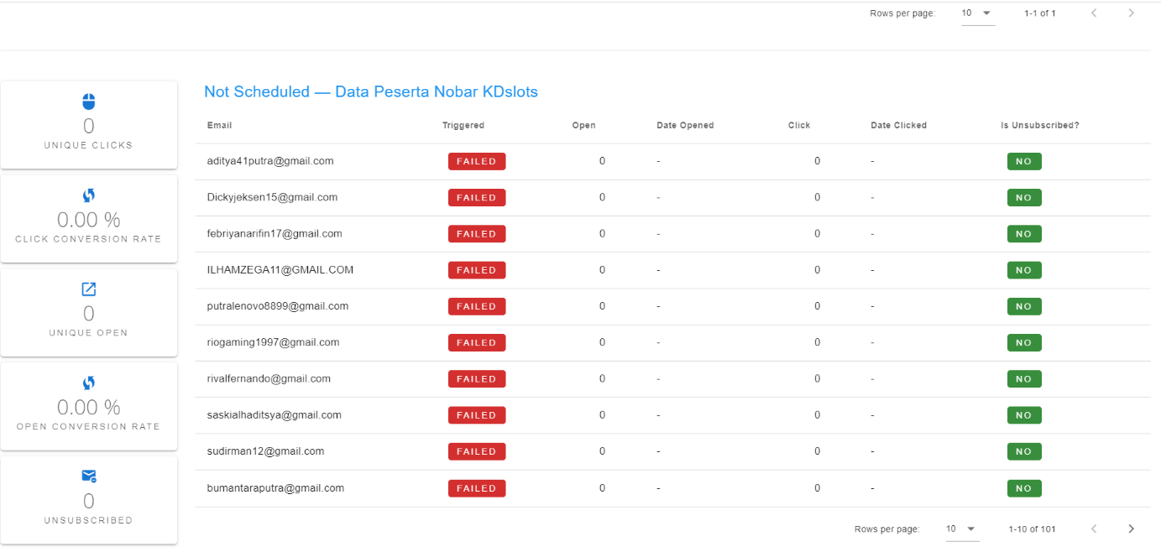
(Figure 6.4 Instance Report Page)
The complete list of the email contacts is within this table in order to show a more specific response in the campaign by the targeted contacts. In order to export this list into an excel file, click the Export button.
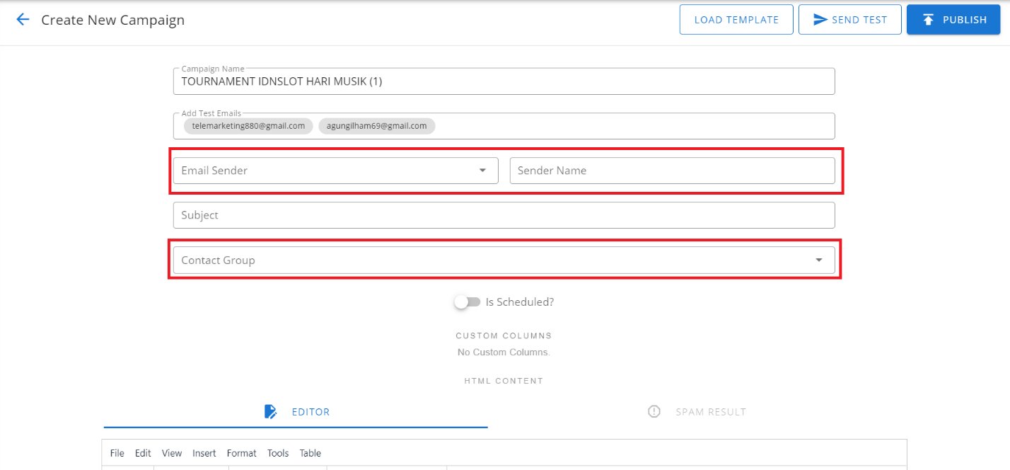
(Figure 6.5 Resend Campaign Page)

Contact Groups
This submodule is where the user can view and create contact groups for sending of email campaign.
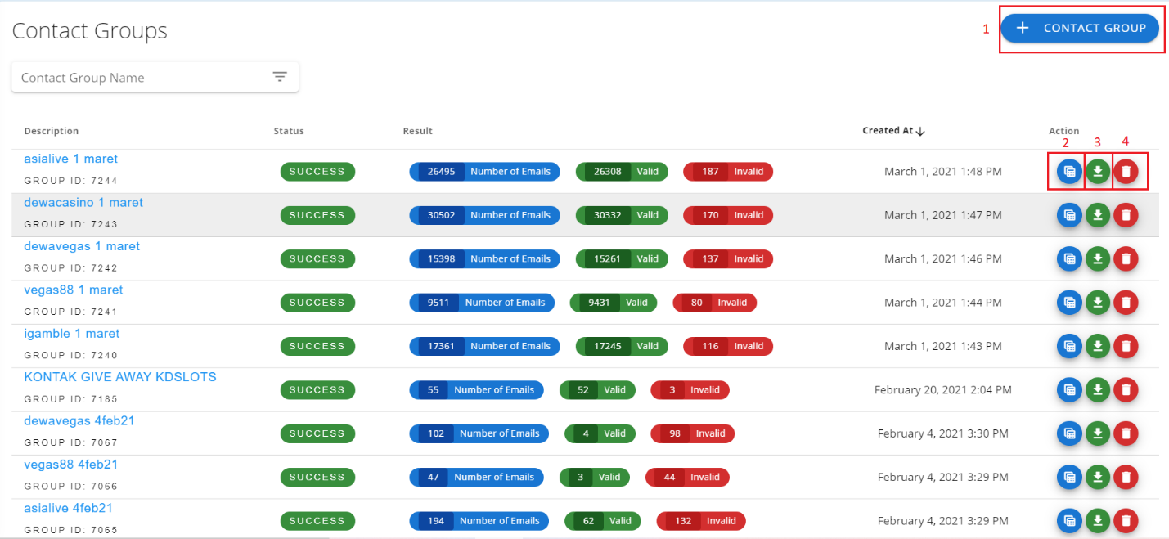
(Figure 6.6 Contact Groups Table)
- This button will redirect the user to Import Contact Groups page. (See Figure 6.7)
- Clicking View List will pop up a modal wherein a table containing the list of emails under the selected contact group is shown. This is where the user can also see to whether a contact is unsubscribed or not yet verified. (See Figure 6.8)
- Download button will export the list of the contacts into an excel file. (still under dev)
- This button will delete a contact group permanently.

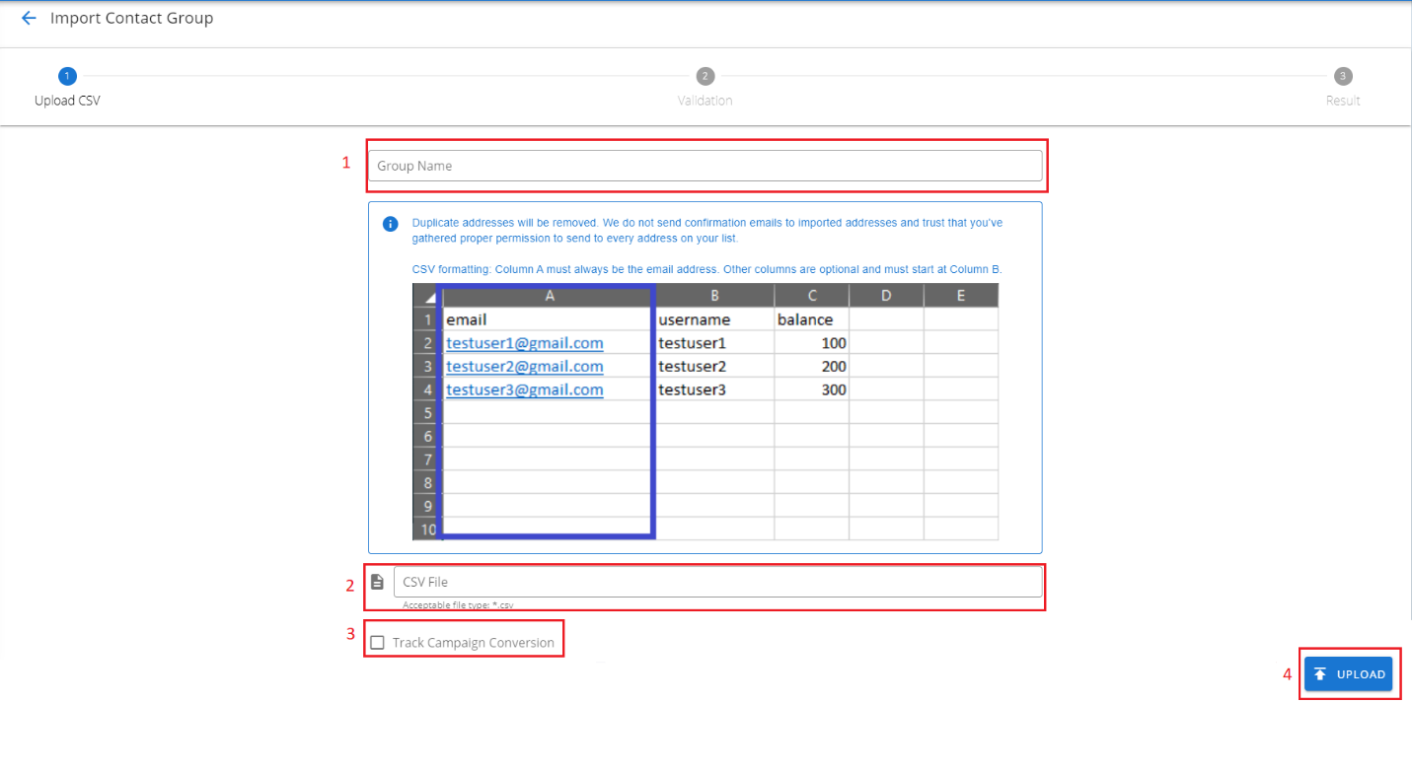
(Figure 6.7 Import Contact Groups Page)
- Add a unique group name for the new contact group.
- Upload the CSV file of the list of the email addresses to be added.
- In order to track this contact group for campaign conversion, tick the checkbox.
- This will trigger the uploading of email addresses into the new contact group, contact list will be seen in validation after uploading.

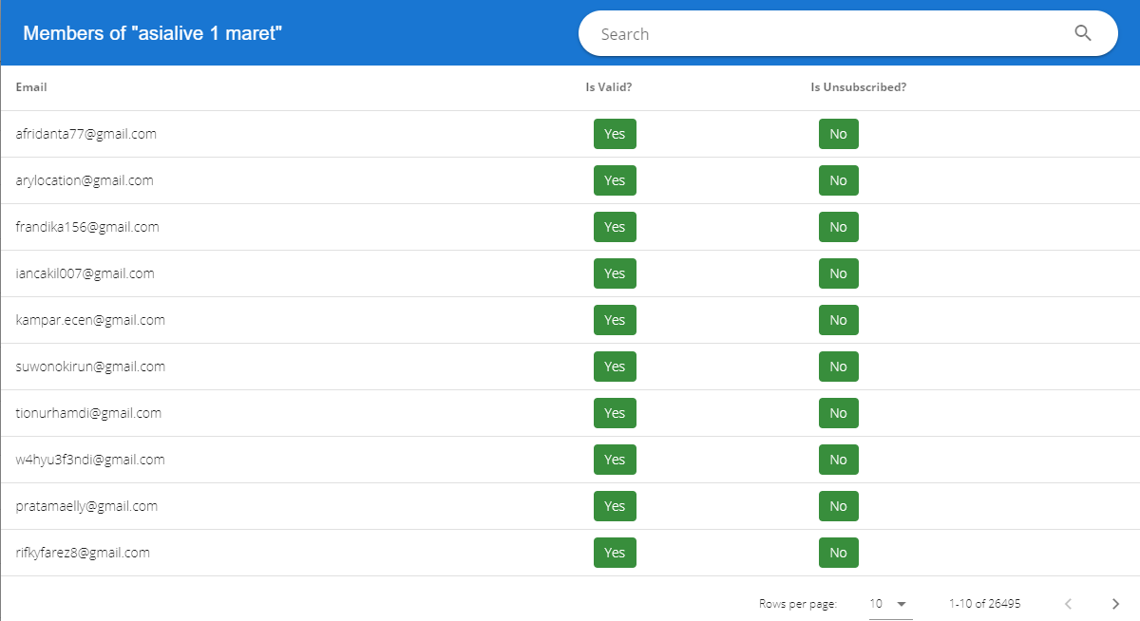
(Figure 6.8 Contact List Modal)

Campaign Conversion
This submodule is where the user can review the responses of the targeted contact groups for a specific campaign including which date the email was opened, their number of deposit and last deposit date.
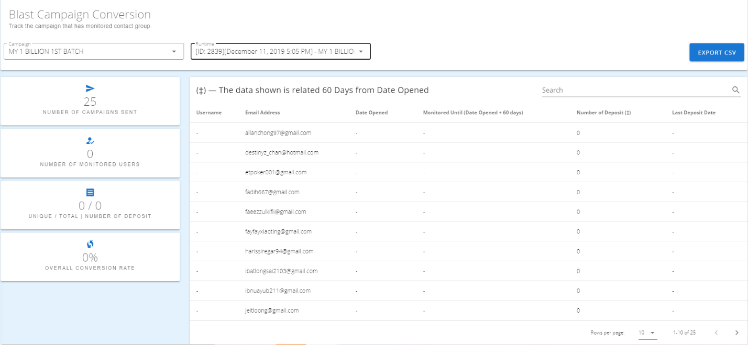
(Figure 6.9 Campaign Conversion Page)

NOTIFICATIOn Blast
This module allows the user to blast users information through announcements, app notification, browser notification or memo. This feature appears alongside a brand depending on its availability of the channel.
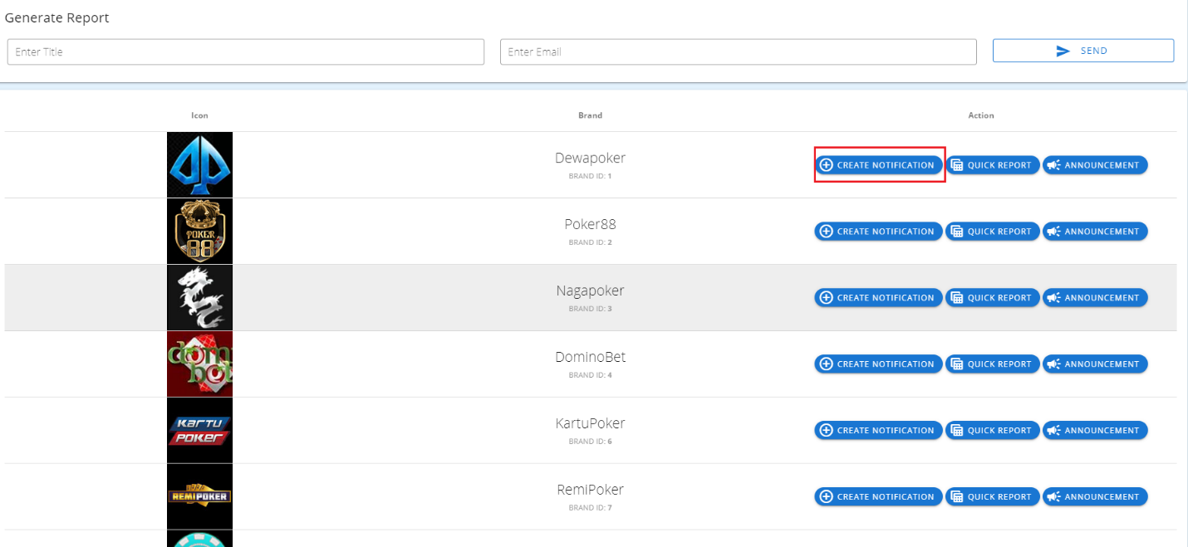
(Figure 7.1 Notification Blast Page)
Create Notification
Upon clicking this button, the user will be directed to a new page to create a browser, email and popup blast. (see figure 7.2)
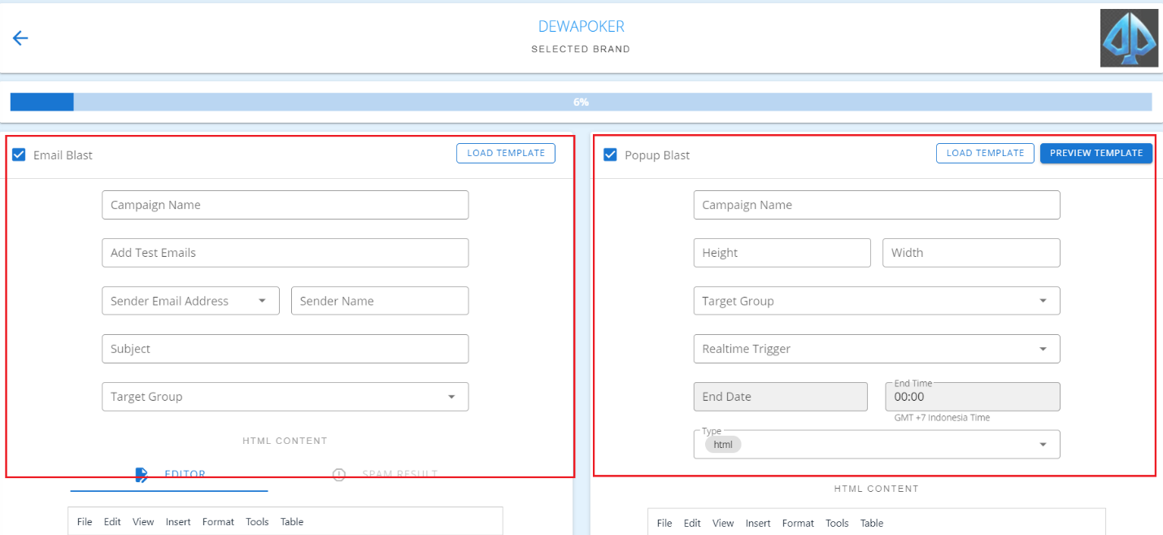
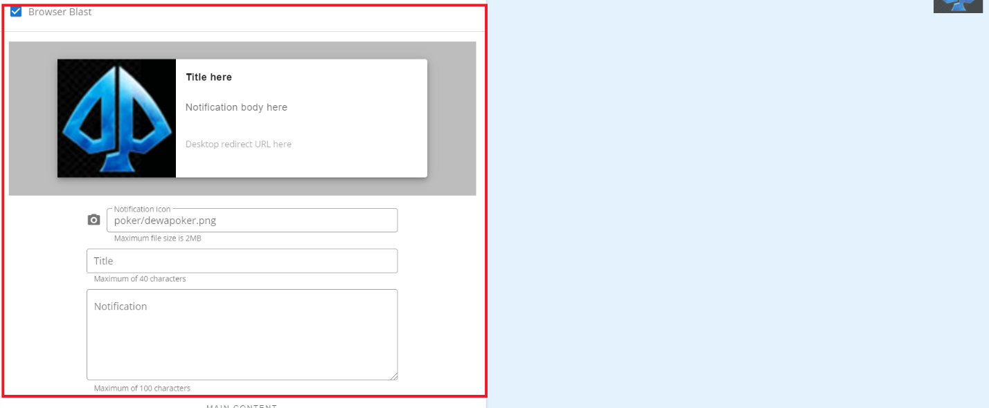
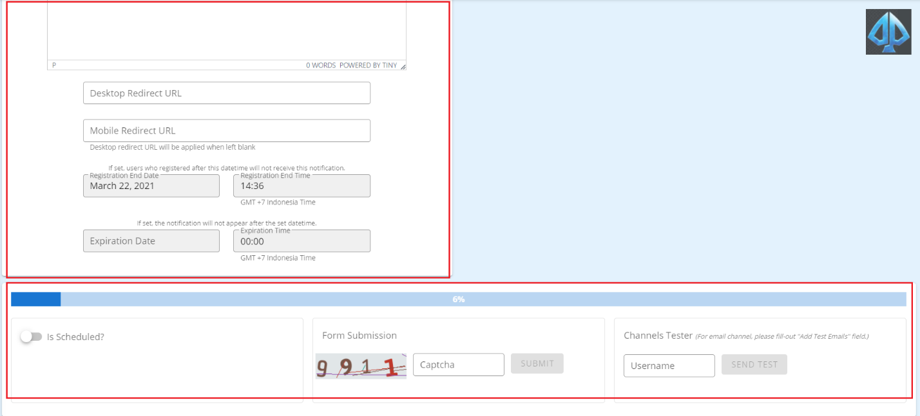
(Figure 7.2 Create Notification Page)
Fill up all the fields. A captcha is required upon creation of blast. In order to test the notification blast first, just fill the username field with a valid username then hit Send Test.

Announcement
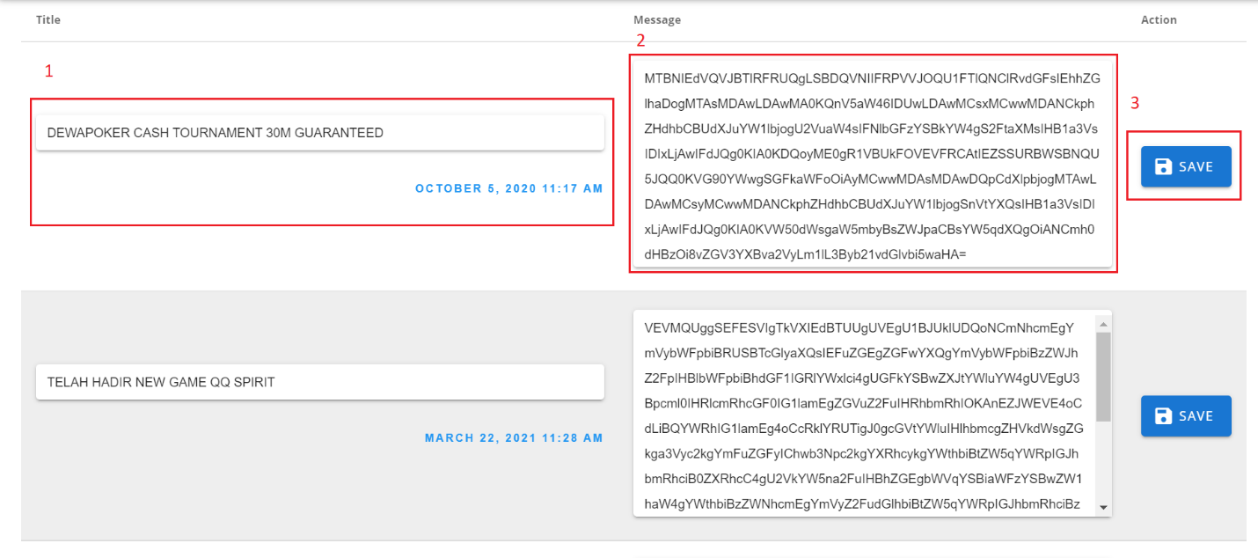
(Figure 7.3 List of Announcement Modal)
- All existing announcements in a specific brand will appear here. Add a title.
- You can update the message.
- Hit the Save button to successfully update an announcement.

Browser Blast
Through this channel, a browser notification would pop up on a user’s screen if it allowed notifications in its browser and if it is its latest subscribed browser. But all users will receive the notification through the brand’s website inside their notification drawers wherein all open and click activities will be tracked.
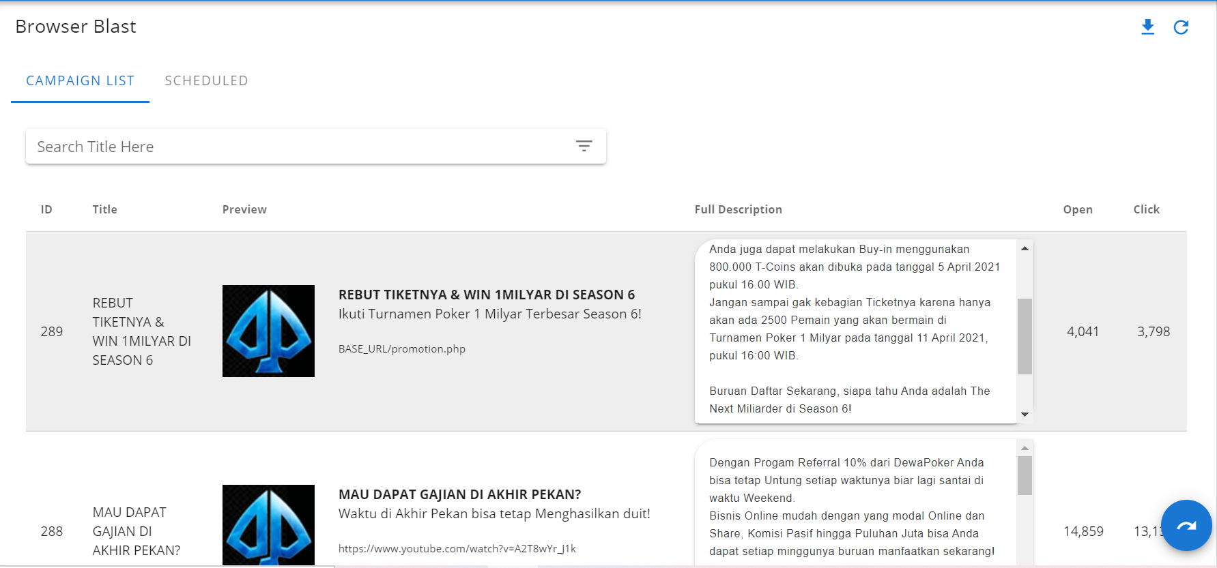
(Figure 7.4 List of Browser Blast Modal)
Alongside a specific browser notification, the user can update it. The user may also send a new one by clicking create notification in the main page. (See Figure 7.1).

Email Blast
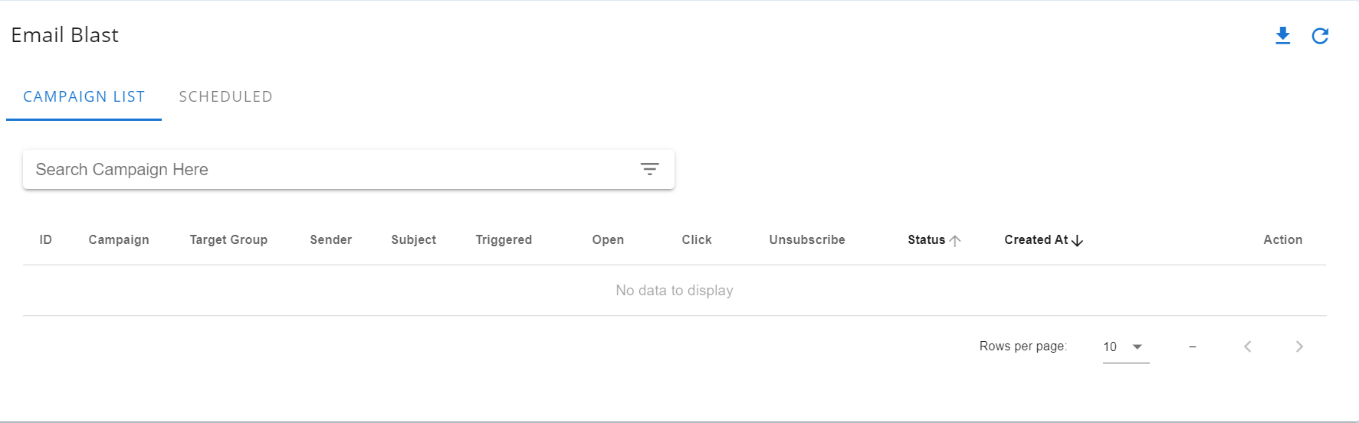
(Figure 7.5 List of Email Blast Modal)
All email are listed inside this model. Alongside each email blast are action buttons: View and Update. View button will load a preview of the email selected by the user. Update button will trigger a modal wherein the user can edit details inside the memo. To send a email blast the user can try clicking create notification in the main page. (See Figure 7.1)
The user may also send a new one by clicking create notification in the main page. (See Figure 7.1).

Popup Blast
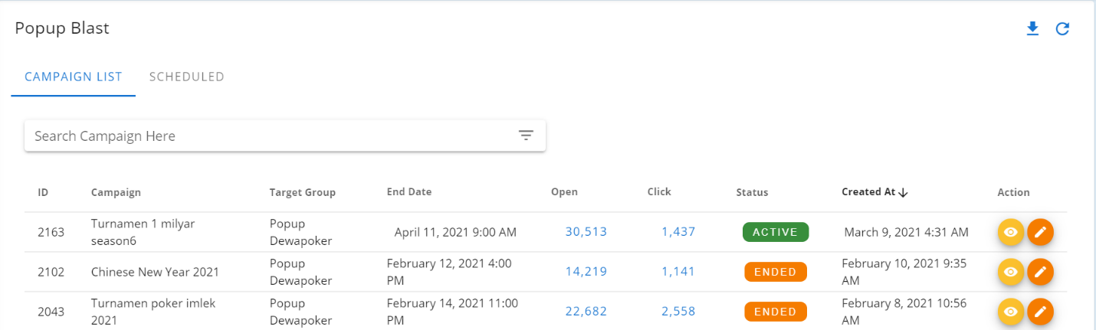
(Figure 7.6 List of Popup Blast)
All popup are listed inside this model. Alongside each popup blast are action buttons: View and Update. View will load a preview of the popup selected by the user.The Update button will trigger a modal wherein the user can edit details inside the memo. To send a new memo the user can try clicking create notification in the main page. (See Figure 7.1)

SETTIngs
This module allows the user to browse all registered users, manage user groups, change segmentation settings, generate API keys for accessing the APIs and add new games.

Manage Users
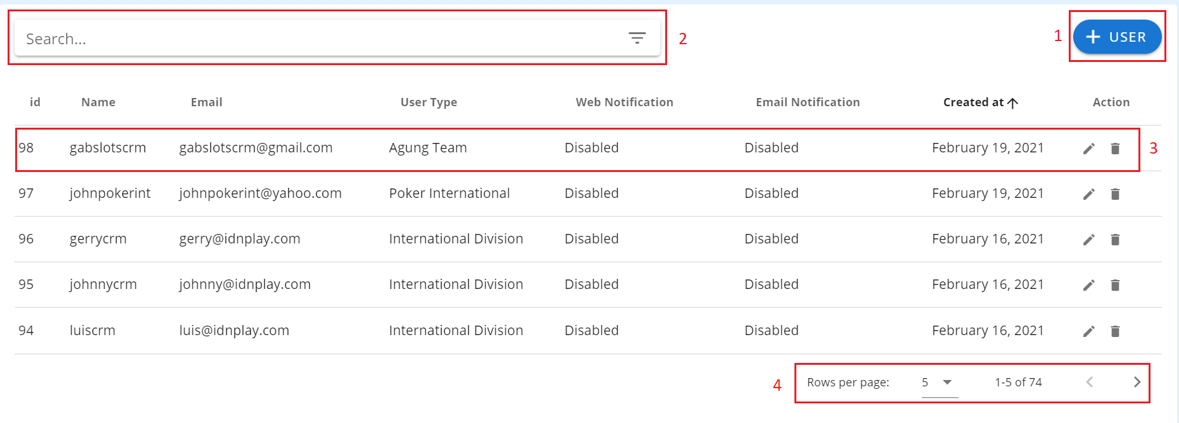
This submodule contains all the information of all registered accounts within the web application and allows them to update or delete it or create a new one.
(Figure 8.1 Manage Users Table)

Creating a new account
- Click the +User button in the upper right of the form. (see Figure 8.1 Label 1)
A page will appear containing fields which must be filled up with valid information. The username, password and passcode must be at least 5 characters After completing the form, click the Submit button. (see Figure 8.2)
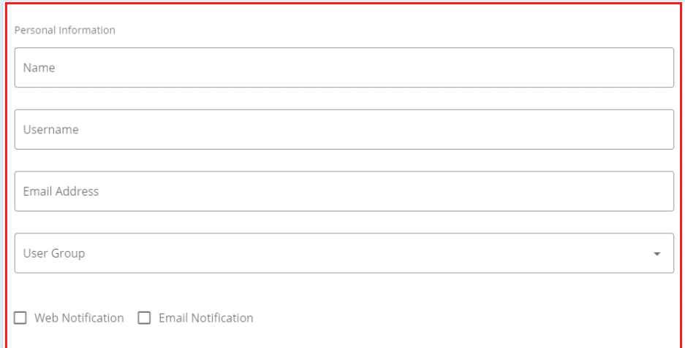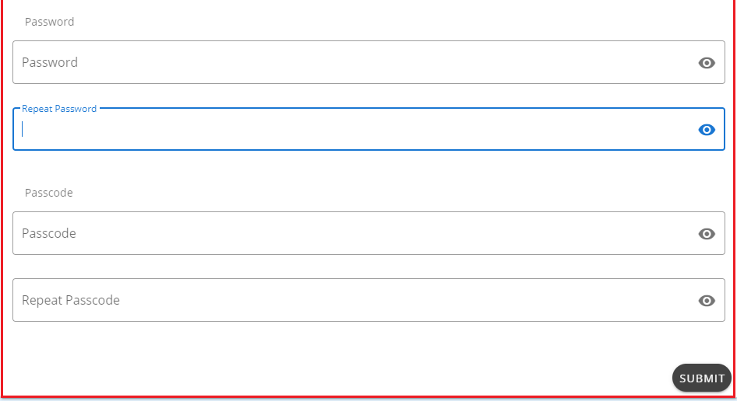

(Figure 8.2 Create Account Page)
Updating an account
- Click the Edit button along the row of the chosen account to be updated. (see Figure 8.1 Label 3)
- A page will appear which contains fields where a user can change its personal information, password and passcode.

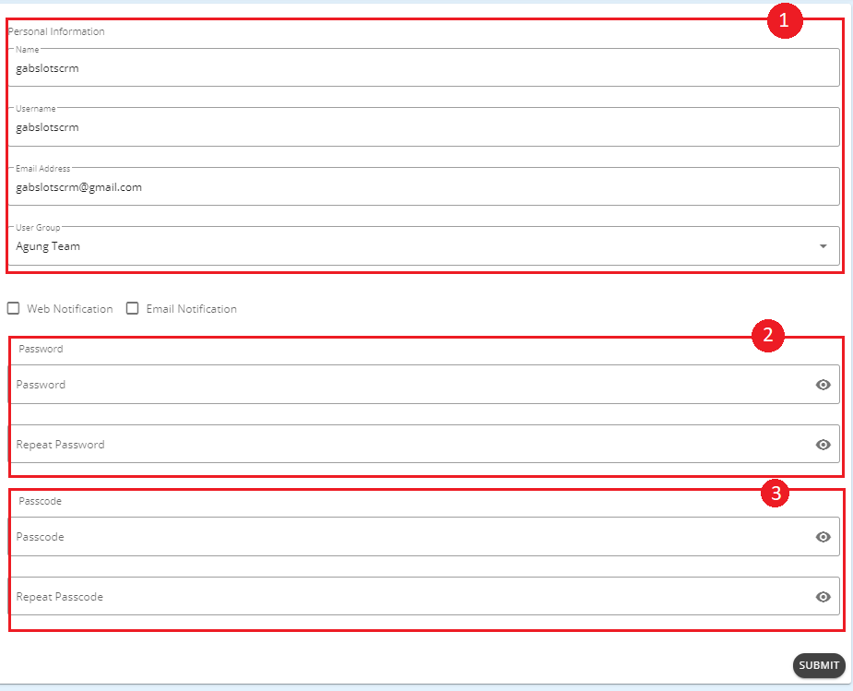
(Figure 8.3 Update Account Page)
  - Personal Information
    - Includes the name, username and the group the user belongs to. The new username must be unique with at least 5 characters. Click the Save button after updating the desired fields. (see Figure 8.3 Label 1)
  - Password
    - Includes fields for the new password. It must be at least 5 characters and the two fields must match. After filling up the fields, click the Save button. (see Figure 8.3 Label 2)
  - Passcode
    - Includes fields for the new passcode. It must be at least 5 characters and the two fields must match. After filling up the fields, click the Save button. (see Figure 8.3 Label 3)
Deleting an account
- Click the Delete button along the row of the chosen account to be deleted. An alert popup will appear for confirmation. To continue deleting click OK, otherwise click Cancel. (see Figure 8.1 Label 3)
Searching for an account
- Use the Search input box in the upper right of the table and type either a full name, team, username or user type, then the table will automatically display the results. (see Figure 8.1 Label 2)
Customizing the number of entries
- Select from the 4 dropdown options in the upper left of the table and it will automatically display results according to the selected number of entries. (see Figure 8.1 Label 4)

Level Access
This submodule contains the different user groups a user may belong to, its module level of access and which games it has access to. It helps in limiting the user by only giving them the access they need in order to operate in the application, thus avoiding unwanted changes which might be made by other users.

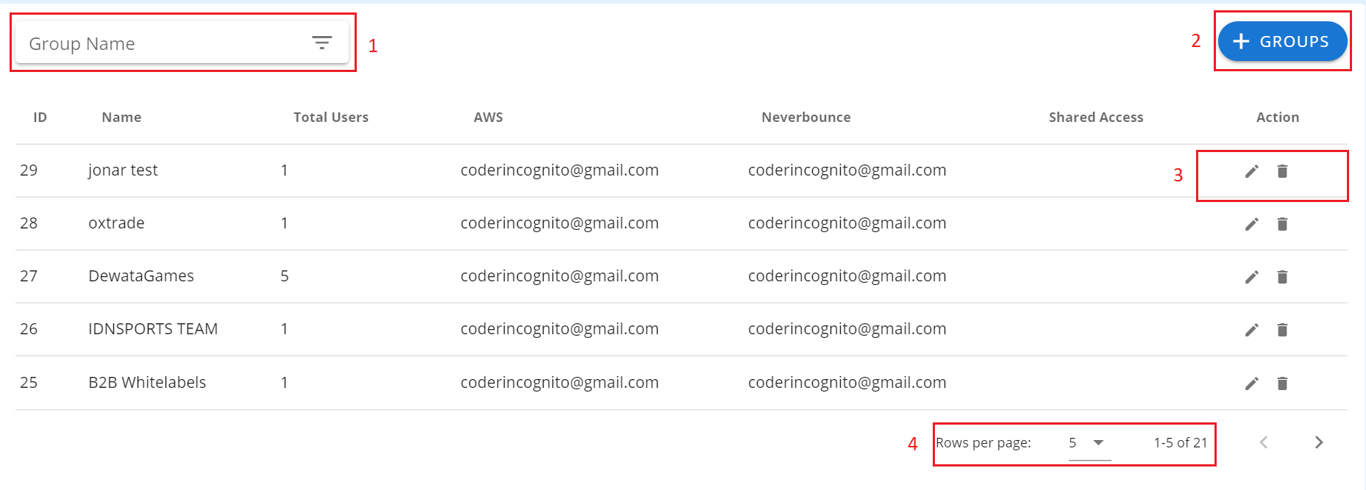
(Figure 8.4 Manage User Groups Table)
Creating a new user group
- Click the + Groups button in the upper left of the form.
- The user will be redirected to a new page containing all the needed fields formed into a group of tabs to create a new user group. The group name must be unique with at least 5 characters and give it at least one game access. The user may then limit the access per module by only ticking the checkboxes alongside the row of the name of the module according to what is desired. After completing the form, click the Submit button at the top.

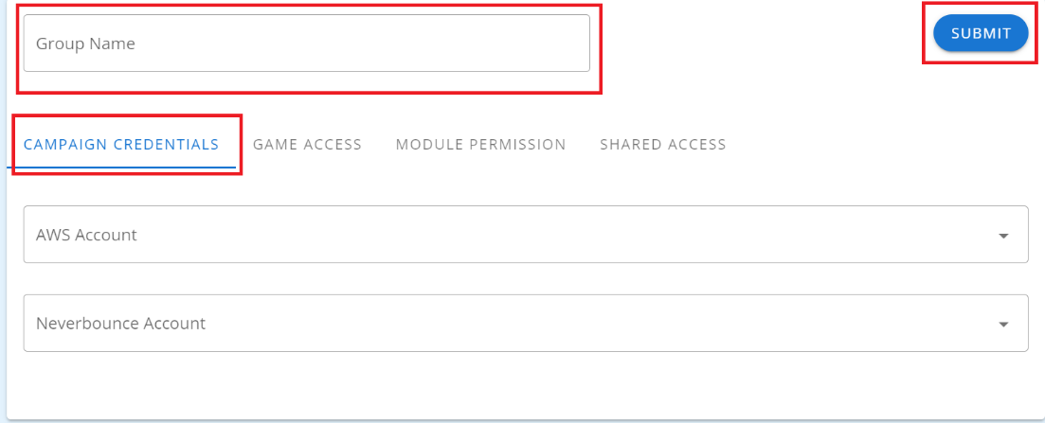
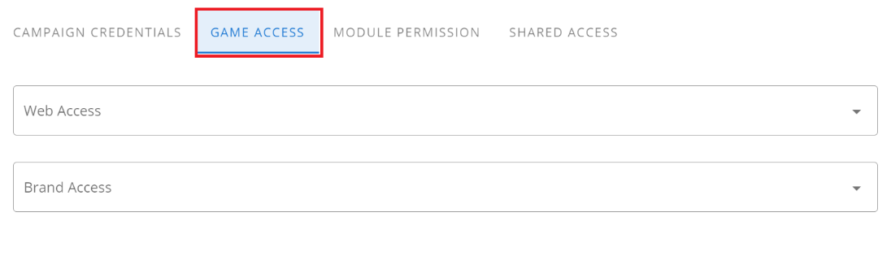
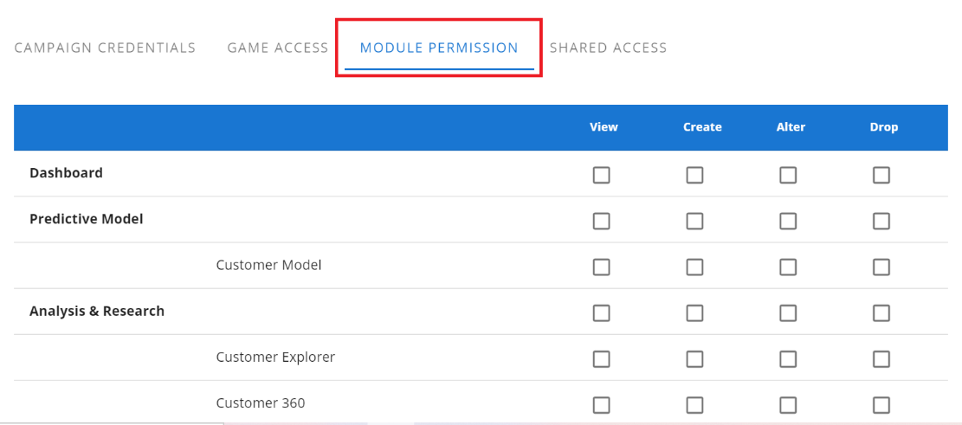
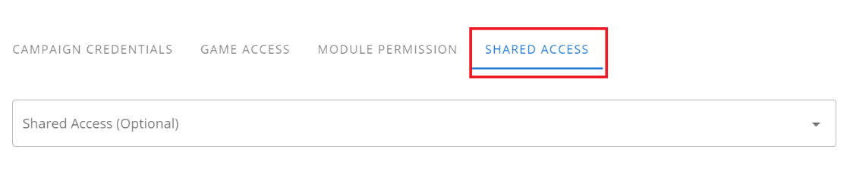
(Figure 8.5 Create User Groups/Edit User Groups Form)

Updating a user group
- Click the Edit button alongside the row of the chosen user group to be updated. (see Figure 8.4 Label 3)
- The user will be redirected to a new page containing the form with all the information about its level of access and may modify them according to their desire. The group name must be unique with at least 5 characters and give it at least one game access. The user may tick or untick the checkboxes alongside the row of a module name to update the user group’s level of access to that specific module. Click the Submit button at the top of the form to save all modifications. (see Figure 8.5)
Deleting a user group
- Click the Delete button alongside the row of the chosen user group to be deleted. An alert popup will appear for confirmation. Click OK to continue, otherwise click Cancel. Note that removing a user group will automatically remove all the game access of a user belonging to that user group, thus resulting to it not being able to do any operation within the application. (see Figure 8.4 Label 3)
Searching for an account
- Use the Search input box in the upper right of the table and type either an ID, group name or a game, then the table will automatically display the results. (see Figure 8.4 Label 1)
Customizing the number of entries
- Select from the 4 dropdown options in the upper left of the table and it will automatically display results according to the selected number of entries. (see Figure 8.4 Label 4)

Segmentation
This submodule contains the settings of conditions for both main and secondary lifecycle segmentation. Segmentations are vital to categorize each player, adding more help in analyzing marketing strategies or creating campaigns depending on the activities of the player. There will be six main lifecycle segmentations namely non-depositor, new, active, reactivated, churn and dormant, while the secondary will include seven namely copper, bronze, silver, gold, diamond, platinum and VIP. Each of the said segmentations has its own different conditions, thus if a player qualifies that specific condition, he/she will belong to it.
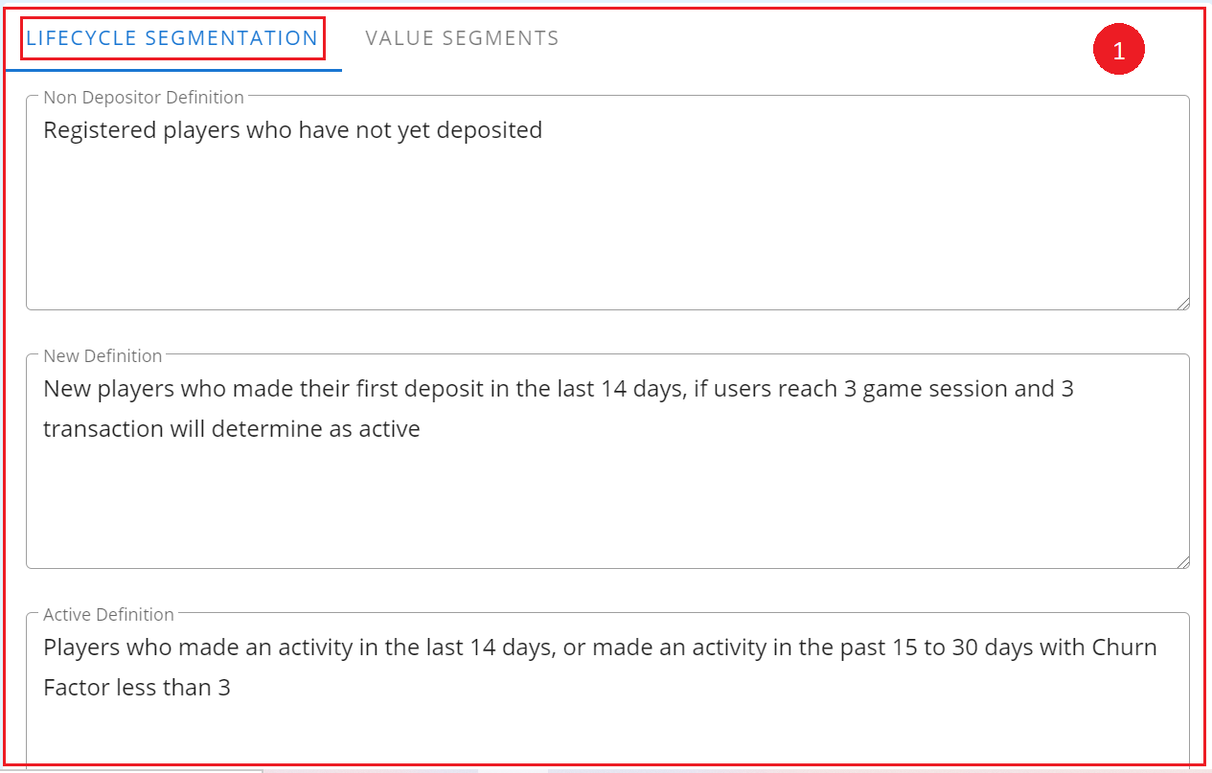
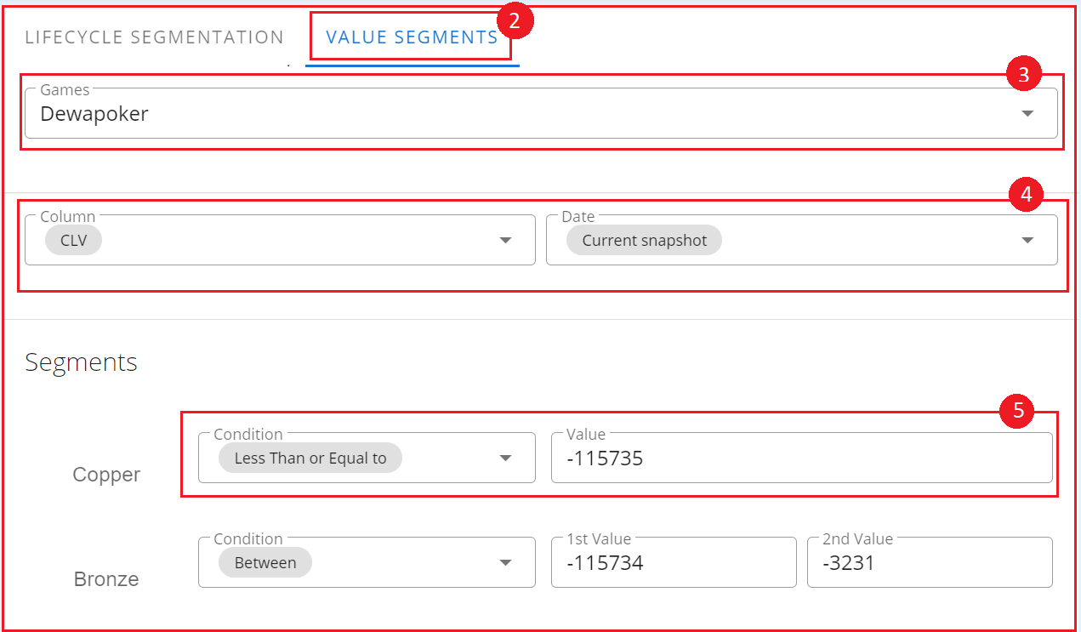
(Figure 8.6 Lifecycle Segmentation Module)

Updating a condition
- The page will automatically load all the settings for both main and secondary lifecycle segmentation. (see Figure 8.6 Labels 1 and 2)
  - Main Segmentation
    - Modify all the fields according to what is desired and click the Save button at the bottom of the form. (see Figure 8.6 Label 1)
  - Secondary Segmentation
    - Each game may have different conditions. Choose a game from the Game dropdown options. (see Figure 8.6 Label 3)
    - Conditions for the selected game will be loaded. Modify them according to what is desired. The user may click the button alongside a condition with the plus icon or the minus icon in order to respectively add or remove a condition. The dropdowns include the column names, date and operations options. (see Figure 8.6 Label 4)
    - In the segments portion, the user may modify the value of the condition and description fields of a specific segment. Click the Save button in order to save all modifications after finishing. (see Figure 8.6 Label 5)

Web Services
The web application itself has its own API. This submodule is the one responsible in creating, updating, deleting and storing all the API keys which will be used when sending requests to the API, thus limiting the users which have access to it. As for the games, the user may also delete or add a new game in this page.

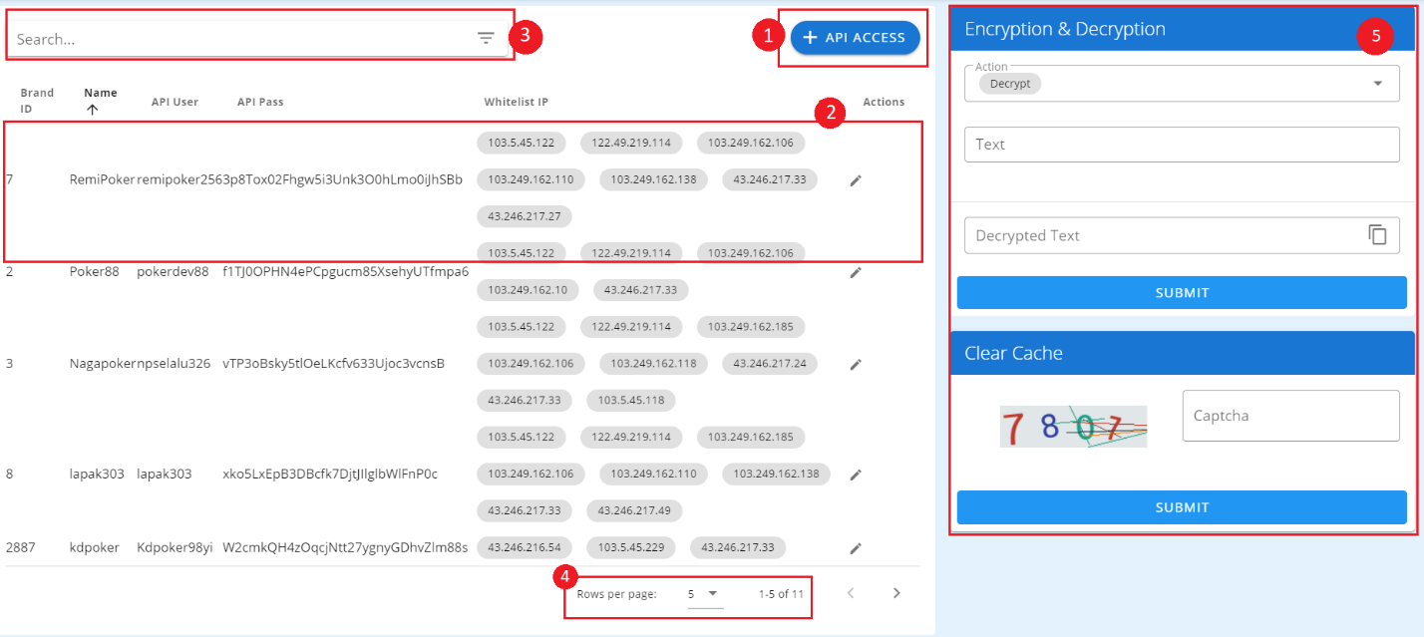
(Figure 8.7 Web Services Module)
Creating a new API access
- Click the + API Access button at the bottom of the Access APIs panel. (see Figure 8.7 Label 1)
- A modal will appear containing all the fields which must be filled up with valid information. The user must be filled with at least 3 characters. Click the New API key button in order to generate a new one. The Host(s) field must be filled with a valid IP address. For multiple addresses, just separate it with a comma (,). Click the Save button. The user will have to choose in which brand the API will be use. (see Figure 8.8)
- The user can also encrypt and decrypt API key in the Encryption and Decryption panel (see fugure 8.7 Label 5).

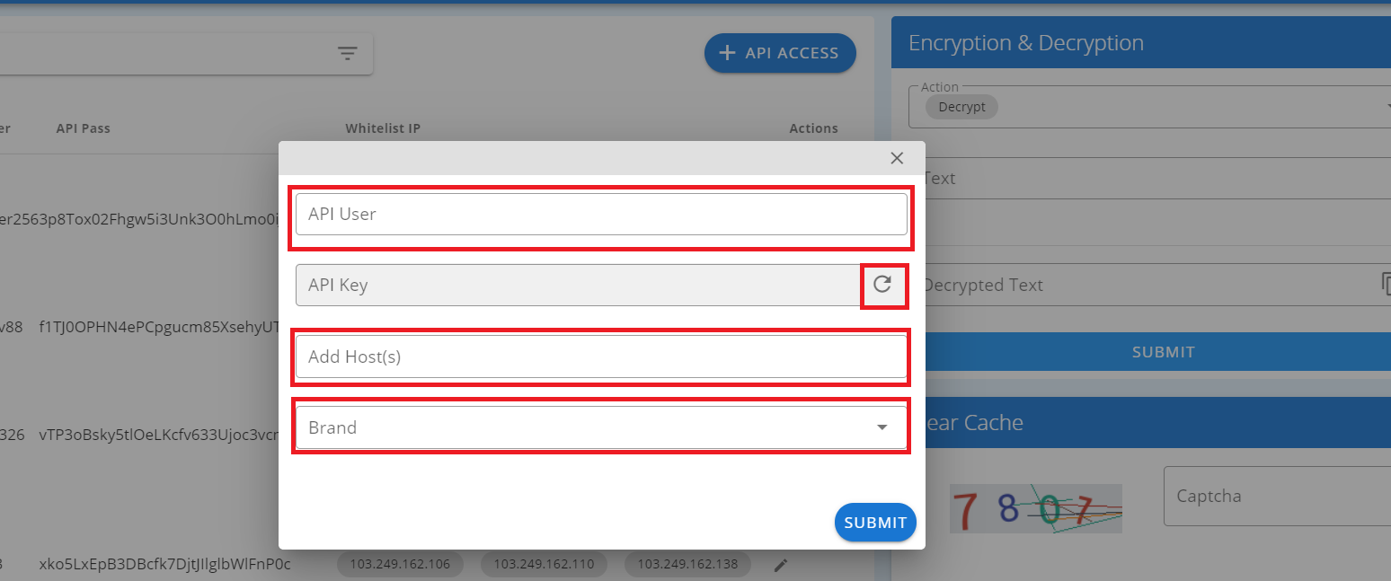
(Figure 8.8 Create Access API/Edit Access API modal)
Editing an API access
- Click the Edit button alongside the row of the chosen API access to update. (see Figure 8.7 Label 2)
- A modal will appear. Modify the fields according to what is desired. Click the Save button. (see Figure 8.8)
Deleting an API access
- Click the Delete button alongside the row of the chosen API access to delete. (see Figure 8.7 Label 2)
- An alert popup will appear for confirmation. Click OK to continue, otherwise click Cancel.
Searching an API access
- Use the Search input box in the upper right of the Access APIs table. Type any information included in any of the columns and the table will automatically load its results. (see Figure 8.7 Label 3)
2. The user can also encrypt and decrypt API key in the Encryption and Decryption panel (see fugure 8.7 Label 5).

Validate User Contacts
This module can be used to modify customer information, even though the system has a function called validate phone and email somehow other system might already validate it, or if the user won’t trust the system validation he/she can use his own.
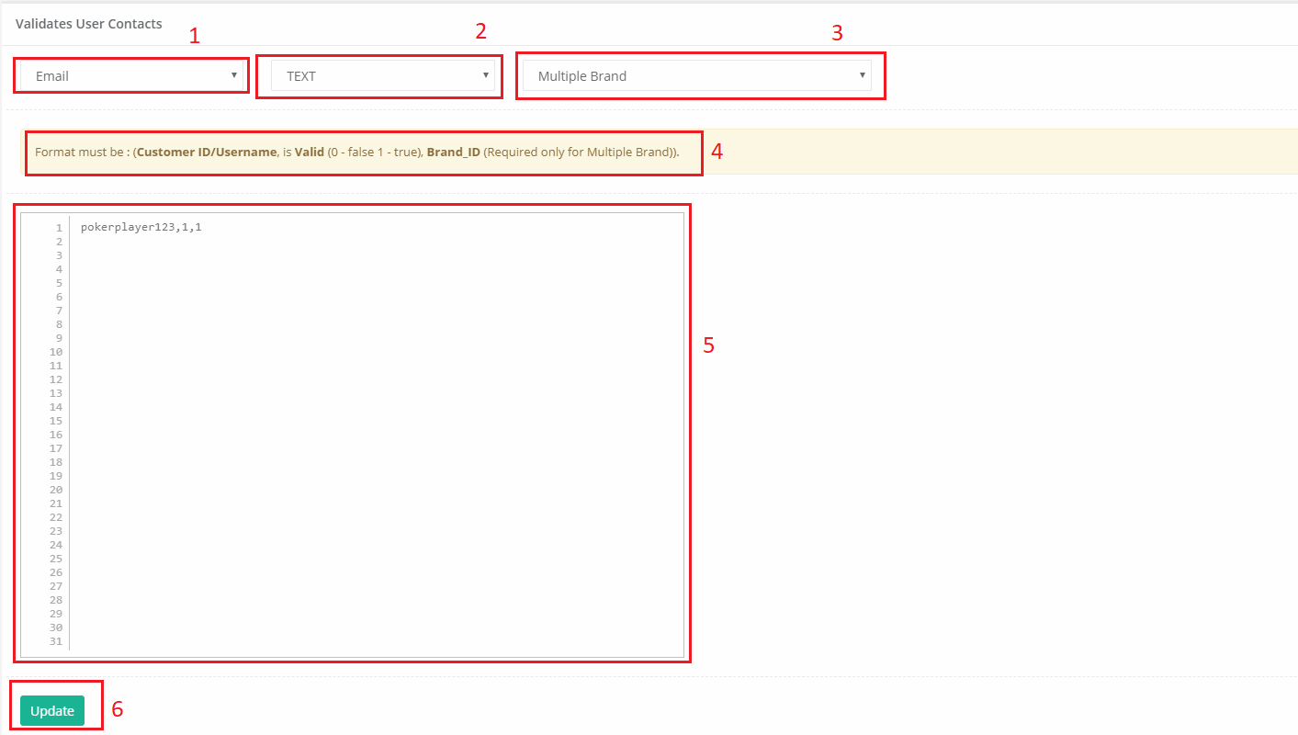
(Figure 8.10 Validate Contact Using Text)
- User Can Choose Either Email or Phone to Validate
- By Click this section system gives the user a different way of update the records.
- User can choose what brand to update or if multiple brand third parameter of the csv or text shouldn’t be existing.
- User should follow this information for update the system database
- This is where user can put the list of customers to update (Username or Customer ID, Valid or not, Brand ID).
- This will trigger the update function.

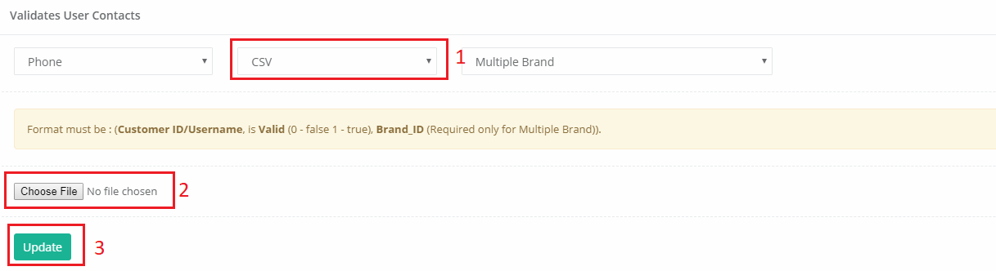
- CSV option or file option.
- Only a Valid CSV file are allowed on this section.
- This will trigger the update function.

Manual Jobs
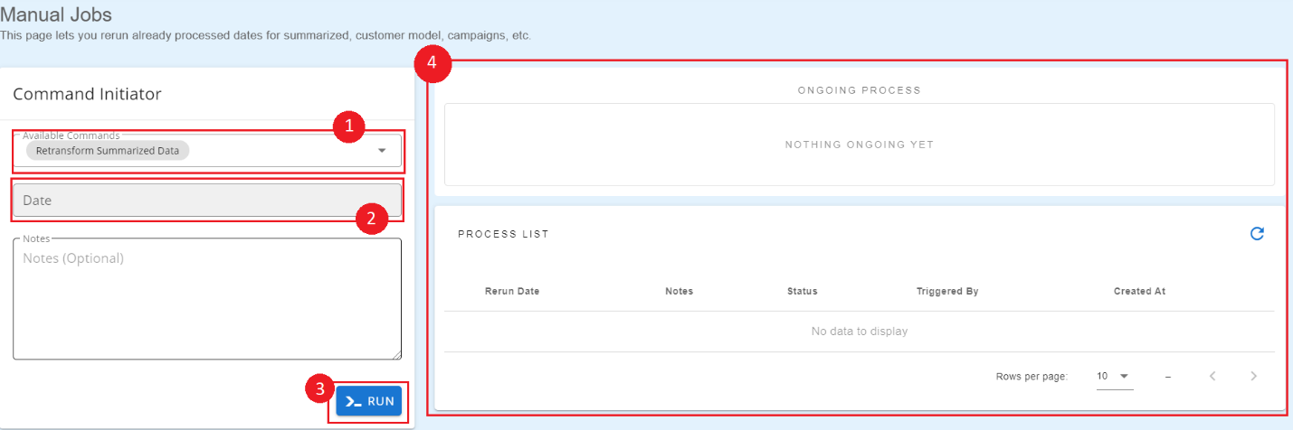
This submodule is to manually run commands inside the CRM tool. This includes re-running of snapshot date, realtime campaign customer assignment, realtime campaign increase calculation, customer model transformation and phone verification.

(Figure 8.11 Manual Re-run of Jobs)
- Choose which command to re-run.
- Choose which date of data the job should be re-run.
- This will trigger the re-run of selected command.
- The current manual jobs running will then be shown in the queued jobs table wherein the status of the command is detailed (whether it is still queued or processing). If a manual job has failed, it will then be inserted on the failed jobs table.

Notifications
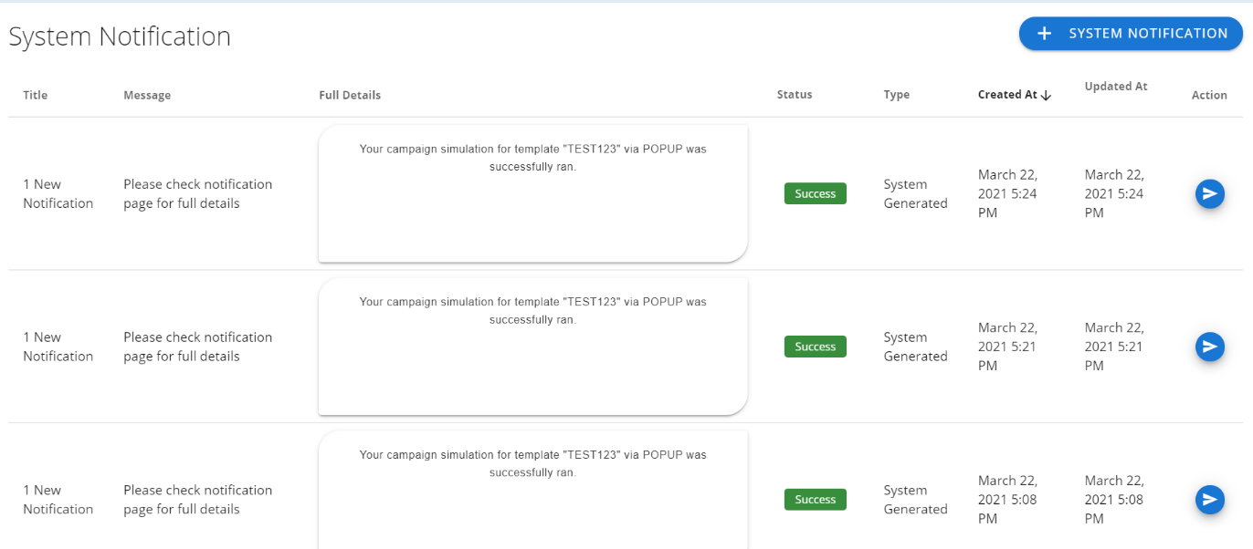
This submodule is for blasting notifications for the users of the CRM Tool. The user can create and send notifications to all or specific users.

(Figure 8.12 Notification Blast List)
A complete list of notifications created by both the system or the users are listed in this table. The administrator then can forward/send this notification to all or selected users.
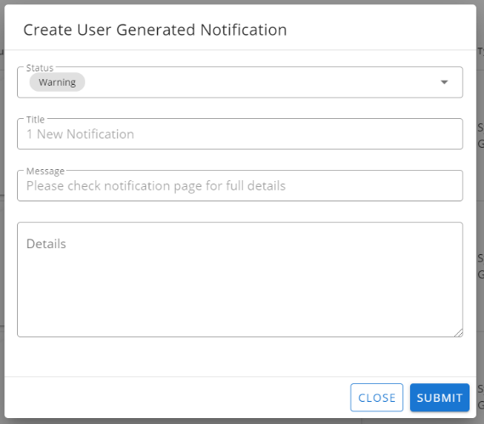
(Figure 8.13 Admin Notification Creation)
A user can manually create a notification in which they have the option to choose which type (success, warning, or error) and the message to be sent.

LOGS
This module contains all the logs of activities made within the whole web application.

Users
This submodule contains all the logs made by all the users to track changes made by each user within the application. It displays a table containing the username alongside specific details which includes the time the user has done a specific action.
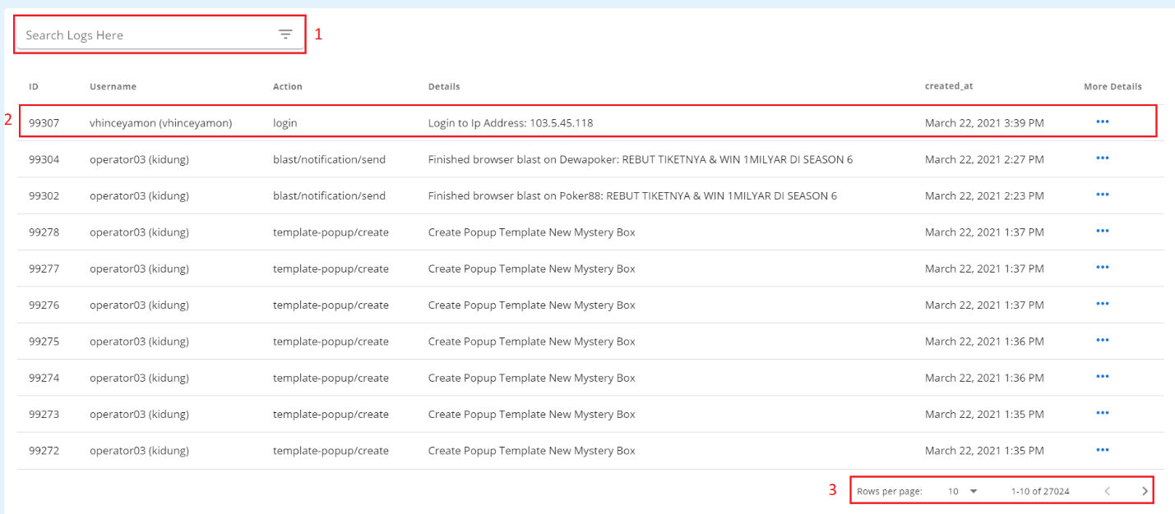
(Figure 9.1 Logs Module)
Searching logs
- Use the Search input box in the upper right of the table and type either a username, detail or action, then the table will automatically display the results. (see Figure 9.1 Label 1)
Customizing the number of entries in the table
- Select from the 4 dropdown options in the upper left of the table and it will automatically display results according to the selected number of entries. (see Figure 9.1 Label 3)
Viewing details for user log
- Click on (…) more details row and modal will appear with more details about the selected user log, to view modal (see figure 9.2).
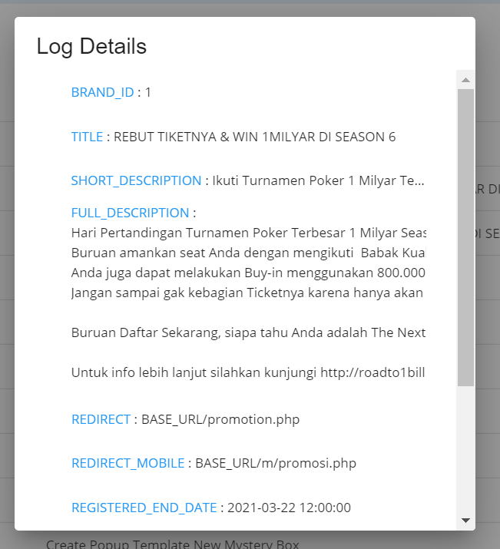
(Figure 9.2 Log Details)

System Monitoring
This module is to generate reports on monitoring the CRM Tool itself. This has three submodules: Server, Queue and Job.

Server
This submodule is responsible for monitoring the activity of the server regarding its downtimes and times with high latency. This also helps on quickly resolving the problem whenever the server becomes down. Generated reports can be exported as excel files.
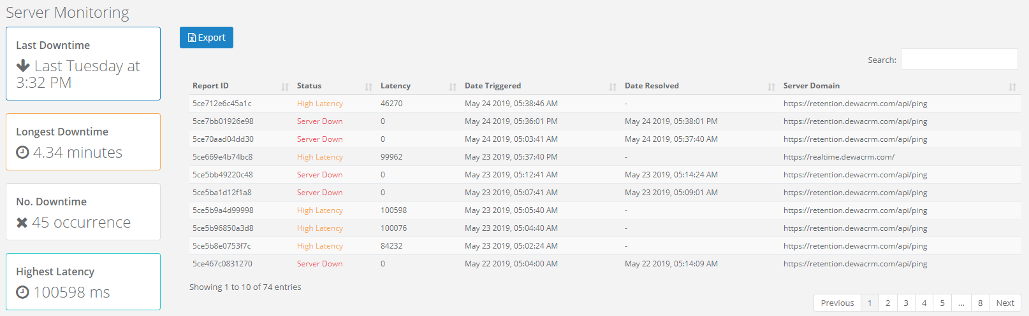
(Figure 10.1 Server Monitoring Table)

Queue
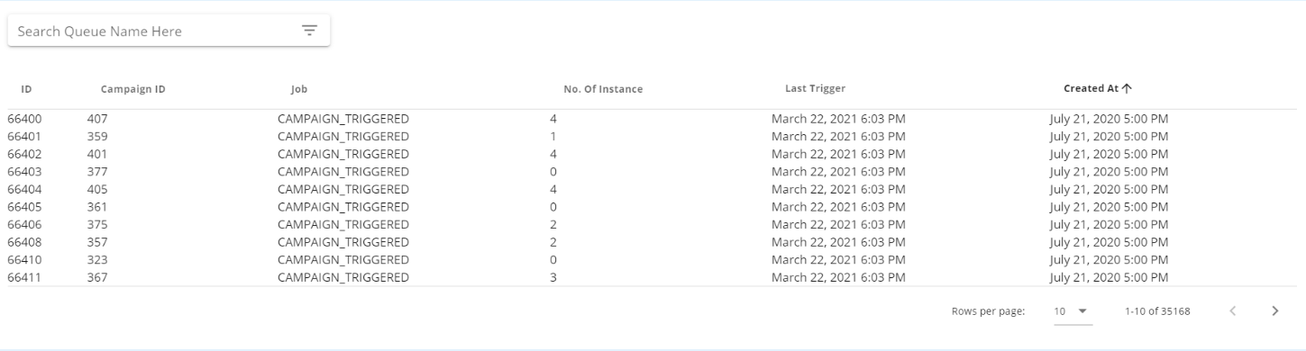
This submodule monitors the queue upon sending of campaigns. Generated data can also be exported as an excel file.

(Figure 10.2 Queue Monitoring Table)

Job
This submodule monitors the jobs run by the CRM including data snapshot, transformation of customer model, assignment of campaign to users and calculation of campaign increase. All data generated can be exported as an excel file.
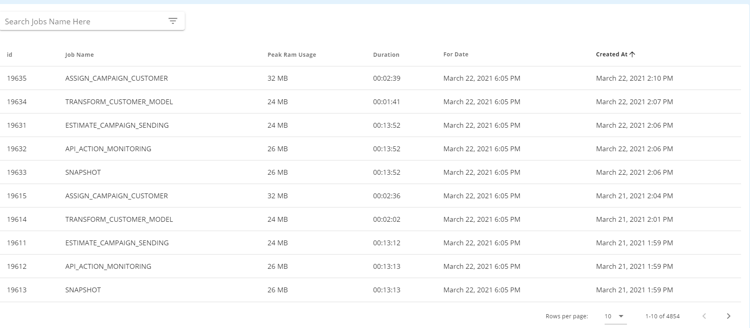
(Figure 10.3 Job Monitoring Table)

